# Turtle Populations

# in the Western Chesapeake and Ohio Canal

# A Thesis in Applied Ecology and Conservation Biology

# By

# Natalie Taylor Haydt

# Submitted in Partial Fulfillment of the Requirements for

# The Degree of Master of Science

# Frostburg State University

# November 2019

**SIGNATORIES PAGE**

**Signatories:**

_____________________________________________________________________

Daniel Hocking, PhD, Assistant Professor of Biology Date

Major Advisor, Frostburg State University

_____________________________________________________________________

Rebekah Taylor, PhD, Associate Professor of Biology Date

Member of Committee, Frostburg State University

____________________________________________________________________­_

Sean Sterrett, PhD, Assistant Professor of Wildlife Ecology Date

Member of Committee, Monmouth University

_____________________________________________________________________

Thomas Serfass, PhD, Professor of Biology Date

Biological Sciences Graduate Program Coordinator

Frostburg State University

_____________________________________________________________________

Thomas Kim Hixson, PhD, Dean of the College of Liberal Arts and Sciences Date

Frostburg State University

### **ACKNOWLEDGEMENTS**

I would like to first thank my thesis advisor, Dr. Daniel Hocking, for all the time and effort he provided in mentorship and guidance for this thesis. He was especially pivotal in the brainstorming and development of my statistical spatial capture-recapture model. I would like to thank the National Park Service for supporting this research (CHOH-2018-SCI-0020). I appreciate the support and advice provided by both Dr. Rebekah Taylor and Dr. Sean Sterrett as members of my committee. I owe a huge thanks to all graduate students, undergraduate students, and others who provided their time and effort to help with spatial capture-recapture field work, including Kristina Grove, Alli Graf, Elizabeth Myers, Tiffany Haydt, Jacey Brooks, Erica Duda, Sara Sprouse, National Park Service Interns, and passing bikers whom helped unstick my field vehicle a couple times. I greatly appreciate the University of Maryland Appalachian Lab and Dr. Matthew Fitzpatrick for providing the computer power necessary to run my SCR model. I would also like to thank Dr. Tom Serfass for his positive encouragement as the graduate program coordinator and both Ms. Cassandra Hunter and Ms. Bebe Elrick as Biology Department Administrative Assistants who helped with graduate requirement administration and organization of thesis events. Also, thank you to Dr. Joe Milanovich for use of additional turtle traps. Lastly, I would like to thank my family and remaining graduate and undergraduate students who supported me throughout my time at Frostburg. Funding for this project was provided by Frostburg State University.

### **ABSTRACT**

More than half of turtle species worldwide are threatened due to habitat loss, invasive species, environmental pollution, disease, unsustainable use, and global climate change. Examining turtle distributions in managed areas can inform decisions and conservation plans protecting turtle populations in these areas and expand our understanding of underlying mechanisms regulating populations. In this study, we conducted spatial capture-recapture procedures on turtles inhabiting sections of the Chesapeake and Ohio Canal. We captured large numbers of Painted Turtles (*C. picta*), Snapping Turtles (*C. serpentina*), Eastern Musk Turtles (*S. odoratus*), and Northern Red-bellied Cooters (*P. rubriventris*). We developed a Bayesian spatial capture-recapture model to estimate densities, home range sizes, and associated capture probability parameters for *C. picta* at 12 sites along 28 km of the canal. We examined the impact of canal depth and forest cover on turtle population densities and the variation in capture probability between sites, sexes, and sampling days. We found large but variable population densities, moderately large short-term home ranges, and low capture probabilities of *C. picta.* This information can set a baseline for understanding turtle populations to inform management of turtles in the Chesapeake and Ohio Canal National Historical Park. It is also the first study to establish methods for using new spatial-capture recapture to quantify densities and home ranges of turtles, which may help to elucidate patterns not previously discernable with traditional mark-recapture techniques.

### **TABLE OF CONTENTS**

ACKNOWLEDGEMENTS iii

ABSTRACT iv

TABLE OF CONTENTS v

LIST OF TABLES vii

LIST OF FIGURES viii

TURTLE DENSITIES AND HOME RANGES ESTIMATED USING SPATIAL CAPTURE-RECAPTURE IN THE CHESAPEAKE AND OHIO CANAL 1

ABSTRACT 1

INTRODUCTION 2

MATERIALS AND METHODS 6

Study Area 6

Study Species 7

Spatial Capture-Recapture Field Procedures 7

Environmental Data Collection 9

Spatial Capture-Recapture Model Development 11

RESULTS 16

DISCUSSION 18

Implications 27

LITERATURE CITED 28

TABLES 36

FIGURES 39

APPENDIX A 46

CHAPTER 1 SUPPLEMENTAL TABLES 46

CHAPTER 1 SUPPLEMENTAL FIGURES 56

APPENDIX B 58

CHAPTER 1 MODEL TEXT 58

### **LIST OF TABLES**

Table 1. Trap number and environmental data averaged per site. Depth represents the average depth for all transects with values additionally averaged per transect. Forest cover represents the proportion of deciduous, evergreen, and mixed forest within a 300 m buffer around each site. We obtained land use data from the National Land Cover Database (NLCD 2016; Yang et al. 2018). 36

Table 2. All model input objects and output parameters with associated symbols and indices (Site, Individual, Trap, Sampling day, Sex). 37

Table 3. Linear regression model results examining variation in density by depth and proportion forest cover. 38

Table 4. Secondary sex characteristics of study species. Secondary sex characteristics were used to determine sex of caught individuals. Ratios for *C. serpentina* calculated as 92% accurate (Dustman 2013). 46

Table 5. Known distributions and conservation threats of aquatic turtles found in the Chesapeake and Ohio National Historic Park (Ernst and Lovich 2009). 47

Table 6. Species Characteristics. Mean daily distances moved from previous literature for *C. serpentina, C. picta, T. scripta elegans, and S. odoratus*. Distances calculated from radio-tracking data unless otherwise noted. No mean daily distances could be found for *P. rubriventris*. J = juvenile, F = female, M = male, m = meters. 48

Table 7. Species Characteristics, reproductive traits, feeding type, and IUCN conservation status of aquatic turtles found in the Chesapeake and Ohio National Historic Park (Buhlmann et al. 2008, Ernst and Lovich 2009, IUCN 2017). 49

Table 8. Coordinates taken on the canal bank adjacent to the most upstream trap (direction = towards Cumberland, MD) for each sampled site. 50

Table 9. Mean and median values for mass and carapace length (CL) and number of recaptures of *C. picta, C. serpentina, P. rubriventris, and S. odoratus* captured from all sites. For mass and carapace length, data in parentheses represent standard deviations. Data in brackets represent minimum and maximum values. For recaptures, data in parentheses represent percent of total captures. F = female, M = male, and U = undetermined. 51

Table 10. All saved model output with associated means, standard deviations (sd), 2.5%, 50%, and 97.5% credible intervals, $R$ values (Rhat), and effective sampling sizes (n.eff). Brackets indicate index of site (1:12) or sex (1:2). 52

### **LIST OF FIGURES**

Figure 1. Location of study sites along the Chesapeake and Ohio Canal and distribution of surrounding land cover (United States National Land Cover Database; NLCD 2016, Yang et al. 2018, ESRI 2019). 39

Figure 2. Top left: Site 5; Top right: Site 7; Bottom: Site 4, also displaying deployed traps. 40

Figure 3. Distribution of *C. picta* density estimates per site and overall capture probability per site (capture probability per trap * number of traps). Yellow center points indicate median values. Dark blue boxes represent values within the 50% credible interval and teal lines represent values within the 90% credible interval. 41

Figure 4. Distribution of *C. picta* capture probabilities estimated per sex. Yellow center points indicate median values. Dark blue boxes represent values within the 50% credible interval and teal lines represent values within the 90% credible interval. 42

Figure 5. Distribution of proportion of *C. picta* females estimated per site. Yellow center points indicate median values. Dark blue boxes represent values within a 50% credible interval and teal lines indicate values within a 90% credible interval. 43

Figure 6. Distribution of *C. picta* capture probability estimates for each of four subsequent sampling days, averaged for all individuals, sexes, and sites. Yellow center points indicate median values. Dark blue boxes represent values within the 50% credible interval and teal lines represent values within the 90% credible interval. 44

Figure 7. Scatter plots and linear regression lines representing A) *C. picta* density per site by canal depth and 2) *C. picta* density per site by forest cover. 45

Figure 8. MCMC trace plots for model estimated total number of *C. picta* individuals per site (1:12), derived densities per site (1:12), and estimated capture probability decay rate ($p0$) per site (1:12) and per sex (1:2; 1 = male, 2 = female). 56

## **TURTLE DENSITIES AND HOME RANGES ESTIMATED USING SPATIAL CAPTURE-RECAPTURE IN THE CHESAPEAKE AND OHIO CANAL**

**Natalie T. Haydt, Sean Sterrett, and Daniel J. Hocking**

### **ABSTRACT**

Estimating turtle densities and movements in managed areas can inform decisions and conservation plans for turtle populations in these areas. We conducted spatial capture-recapture of turtles inhabiting western sections of the Chesapeake and Ohio Canal. We developed a Bayesian spatial capture-recapture model to estimate turtle densities, home ranges, and associated capture probability parameters at 12 sites along 28 km of the canal. We examined the impact of site depth and nearby forest cover on turtle population densities and estimated variation in capture probability over time and between sites and sexes. We additionally derived linear home range distances from our model and examined whether they differed between sites or sexes. Density estimates indicated large but highly variable populations of Painted Turtles (*C. picta*) among sites (110 to 650 turtles per 100 m). We did not find a significant effect of either depth or forest cover on *C. picta* densities. Home range distances did not differ by sex but ranged from 248 m to 760 m between sites. Results from this study can inform management of turtle species in the Chesapeake and Ohio Canal National Historic Park, allowing researchers to better understand densities, movements, and capture probabilities of turtles in canal sections targeted for management.

### **INTRODUCTION**

Turtles fulfill a variety of roles in both terrestrial and aquatic ecosystems. They disperse seeds, alter vegetation structure, influence invertebrate populations, and help maintain clean water in aquatic systems by scavenging dead organisms and predating upon weak or sick organisms (Ernst and Lovich 2009, Van Dijk 2010, Lovich et al. 2018). Due to their potential for high biomass and bony shells, turtles likely influence mineral cycles, especially in nutrient deficient systems (Ernst and Lovich 2009, Sterrett et al. 2015). Turtle populations are subject to a wide range of threats including habitat loss and degradation, introduced invasive species, environmental pollution, disease, unsustainable collection, and global climate change (Gibbons et al. 2000, Ernst and Lovich 2009, Lovich et al. 2018). Additionally, turtles have a unique set of life history traits, including being late to sexually mature and being long-lived, which adds to their conservation challenges. Due to turtles displaying a combination of long adult life-spans, low annual juvenile survivorship, and high annual adult survivorship, turtle populations are especially sensitive to threats impacting adult survival and reproduction, as high annual adult survival and resulting reproduction helps stabilize juvenile recruitment (Ernst and Lovich 2009, Van Dijk 2010).

As a result of numerous pressures and demographic sensitivity, 60.4% of modern turtle species evaluated worldwide by the International Union for Conservation of Nature (IUCN) in 2017 were considered threatened following IUCN protocol (categorized as vulnerable, endangered, or critically endangered; IUCN 2017). Yet, turtle species are often overlooked in management plans commonly aimed towards protecting bird and mammal species (Roll et al. 2017). In this respect, consideration of turtle species in conservation planning, including in already managed areas, is vital to maintaining global turtle populations.

Management plans for natural areas can be informed by turtle demographics, such as population size, density, recruitment rates, and death rates. These estimates can guide identification of both vulnerable and stable populations and allow conservationists to target areas in need of restoration or areas that might serve as stable reservoirs. Through capture-mark-recapture (CMR), reliable estimates of population size and other demographics can be obtained, while accounting for detection variability (Mazerolle et al. 2007, Nichols 2014, Sutherland and Royle 2016). These methods are not spatially explicit, or do not involve locations of individuals within a studied area in estimation of densities (Royle et al. 2014). Instead, traditional CMR models estimate population sizes at associated field sites and divide population sizes by an arbitrary area to derive densities, often resulting in inaccurate or inconsistent calculations of density and space use (Wilson and Anderson 1985, Royle and Young 2008, Royle et al. 2014).

Spatial-capture-recapture (SCR) procedures and models allow for more accurate estimation of parameters arising from individual space use and movement (Royle et al. 2014). New SCR techniques allow for the estimation of abundance, density, dispersal, home-range, habitat selection, landscape connectivity, survival, and recruitment (Royle et al. 2014). Parameters such as population densities and individual activity centers (centroid of space used during trapping session, often interchangeable with home range center) are defined within a specified area or state space (Royle et al. 2014, Muñoz et al. 2016, Sutherland et al. 2016). SCR models estimate the rate of decline in capture probability with distance from activity centers, and researchers can additionally derive home range sizes from the standard deviation of this response curve, or sigma ($σ$; Royle et al. 2014). Standard home range estimation using multiple convex polygons (MCP; Mohr 1947, Southwood 1966) tends to overestimate true area usage (Franzreb 2006). MCP estimation often provides substantial information on amount of area used over seasons or years but can unintentionally incorporate atypical long distance movements (White and Garrott 1990). In contrast, SCR derived home range sizes are more indicative of typical movements occurring over sampling sessions and in closed SCR models, individuals are assumed to not display long distance dispersal or migratory movements (Royle et al. 2014). Because SCR derived home range sizes are associated with capture probability, they are less likely to overestimate true area usage of individuals, and rather indicate the area an individual is likely to occupy over a specified time. Similar to home ranges estimated from kernel density methods, SCR derived home ranges can exclude important areas that are not often used (Worton 1987). In contrast to standard home range estimation methods, SCR estimates are constrained to the often shorter time spans associated with SCR sampling sessions and estimates can be biased if traps impact individual space usage (Royle et al. 2014).

Over the past decade, SCR methodology and its derivatives have been conducted on organisms such as feral pigs (Jiménez et al. 2017), Andean Bears (Molina et al. 2017), grizzly bears (Boulanger et al. 2018), grey wolves (Mattioli et al. 2018), leopards (Gray and Prum 2011), jaguars (Sollmann et al. 2011), American minks (Fuller et al. 2016), wolverines (Royle et al. 2011), salamanders (Sutherland et al. 2016), and fish (Raabe et al. 2014). Currently, researchers have yet to conduct SCR analysis on aquatic turtle populations. By applying SCR to turtle populations, researchers can examine population densities in delineated areas and calculate home range estimates and short-term movements (Royle et al. 2018). Furthermore, comparing densities between sites in a managed system can potentially elucidate habitat characteristics that most impact population abundance.

The Chesapeake and Ohio Canal (C&O Canal), managed by the National Park Service as part of the Chesapeake and Ohio National Historical Park, is inhabited by a variety of turtle species. Built in 1828, the canal ran from Washington D.C. to Cumberland, MD and served as a major transport path for resources such as coal, lumber, and agricultural products for Potomac communities (National Park Service 1991). The system was shut down in 1924 due to excessive flooding (National Park Service 1991, Thomas et al. 2014). The canal system now consists of varying sized ephemeral and permanent pools within a 297-km linear system (Thomas et al. 2014). Due to the park’s narrow and linear structure, the canal’s ecosystem and its inhabited species are especially vulnerable to surrounding land use and vegetation (Thomas et al. 2014). The 2014 National Resource Condition Assessment found impervious surface within and surrounding the park to be less than the 10% reference condition, and impervious surface coverage adjacent to the park was highest near both Cumberland, Maryland and Washington D.C. (Thomas et al. 2014). Additionally, Thomas et al. (2014) estimated forest cover adjacent to the park to be 50%, less than the 59% reference condition and considered degraded.

Multiple turtle species can be found in the C&O Canal and examining the impact of potential biologically important variables, such as depth and percent forest cover, can inform future management of conditions affecting turtles along the C&O Canal. We conducted SCR procedures on turtles at 12 sites along the C&O Canal. This study addressed two objectives. First, we estimated turtle densities, home range size, and capture probabilities for the most abundant species caught at each of the 12 sites. Second, we examined the impact of canal depth and percent forest cover on the model estimated densities.

### **MATERIALS AND METHODS**

#### **Study Area**

We conducted field work along a 28-km stretch of the western portion of the C&O Canal, from Oldtown to Cumberland, Maryland U.S.A. (Figure 1). This portion of the C&O Canal includes a hydrologically augmented section (hereafter: water-fed) located in Oldtown, Maryland intermixing water diverted from the Potomac with water from connected streams and seepages. In 1945, volunteers re-watered and dammed a 7.4-km stretch from Oldtown, Maryland to Town Creek, Maryland (between locks 71 to 68) to serve as a fishing area. Due to the occurrence of re-watering, restorations, damming, dredging, as well as natural degradation of canal, depth along the canal varies drastically. This provides a gradient of available aquatic habitat for turtles with varying depths at different canal sections.

The sampled canal section contained a mosaic of open water stretches and stretches dominated by water lilies or other aquatic vegetation. Surrounding habitat includes a bike trail along the northern edge of the canal that previously served as the barge towpath (Figure 2). Forest brackets both sides of the canal and composes approximately 69% of the C&O National Historical Park plus the surrounding area (5X park area; Thomas et al. 2014). Forested areas and fields adjacent to the canal are occasionally broken up by small ephemeral wetlands and pasture and crop land is interspersed between the canal and the Potomac River (Thomas et al. 2014). Additionally, human development such as roads and houses create a matrix of impervious surfaces alongside the canal. Impervious surfaces constitute about 4.7% of the park and surrounding area and roads comprise 2.3 km per square km of park and surrounding area (See Figure 1 for land use surrounding the C&O Canal; Thomas et al. 2014).

#### **Study Species**

Turtle species documented in the Chesapeake and Ohio Canal National Historic Park likely to be captured by aquatic traps included the snapping turtle (*Chelydra serpentina*), midland painted turtle (*Chrysemys picta marginata*), eastern painted turtle (*Chrysemys picta picta*), red-eared slider (*Trachemys scripta elegans*), northern red-bellied cooter (*Pseudemys rubriventris*), and eastern musk turtle (*Sternotherus odoratus*).

*Chelydra serpentina*, *C. picta*, and *T. scripta elegans* are common in the state of Maryland, precluding a conservation status and are all species of least concern world-wide (IUCN 2017). *Trachemys scripta elegans* is considered invasive in the state of Maryland (Maryland Department of Natural Resources). *Pseudemys rubriventris* is considered stable in Maryland, but is listed as state rare in West Virginia, state rare/vulnerable in Pennsylvania (Maryland Department of Natural Resources), and near threatened worldwide (IUCN 2017). In 2015, Maryland Department of Natural Resources listed *P. ruvriventris* as a regional species of conservation need in the Northeast region (Maryland Department of Natural Resources 2016).

#### **Spatial Capture-Recapture Field Procedures**

We conducted spatial capture-recapture procedures at 12 sites along the Chesapeake and Ohio Canal from 7 June – 19 August 2018 (Figure 1). We conducted spatial capture-recapture procedures for four days at each site. We set 7 – 14 hoop net traps (large = diameter: 0.9 m, mesh: 2.5 cm; medium = diameter: 0.8 m, mesh: 4.0 cm) approximately 5 m from the canal bank 25 m apart within each trap line. Trap lines ranged from 150 – 325 m based on the length of the section that was of consistent depth, width, and vegetative conditions. We chose a 25-m increment resolution to ensure trapping histories would be representative of turtle movements (Royle et al. 2014; see Appendix A, Table 6 for research on daily distances moved). We checked traps daily for four days.

We baited each trap with one perforated, lidded can of Kal Kan ® Complete dry dog food. We chose dog food as it was found to be more efficient at attracting turtles compared to canned sardines (Mali et al. 2014). Traps were submerged deep enough so water levels would cover trap funnels but would be unlikely to completely cover traps over the following 24 hours (e.g., due to precipitation). On each sampling day, we pulled traps from the canal and collected captured turtles in plastic buckets for measuring and identification.

For each turtle, we measured and recorded mid-line carapace length, maximum carapace length, plastron length, maximum depth, and mass. We assessed each turtle’s sex by examining secondary sex characteristics of Emydidae and Kinosternidae and by calculating the ratio of plastron posterior lobe to precloacal length of Chelydridae (Dustman 2013)*.* For all turtles caught, with the exception of large *C. serpentina*, we provided a unique code and used metal files to create square notches along the turtle’s marginal scutes following a numerical coding system (Cagle 1939). For larger *C. serpentina*, we drilled small holes near the edges of their marginal scutes following the same ID system restricted to the rear marginal scutes.

To help increase identification accuracy, we took one photograph of each newly marked individual. Each photograph pictured an individual’s carapace and an adjacent whiteboard labelled with species, identification number, site letter, and date captured. Both new and recaptured individuals were photographed. We saved photographs as references for future identification dilemmas (e.g., double marks). For each turtle, we recorded its identification code and whether it was new or a recapture. Trapping and marking procedures followed protocol approved by Frostburg State University IACUC (A2018-012), the National Park Service (CHOH-2018-SCI-0020), and associated State Permits (56702, 56759).

After mark-recapture data was obtained, we released individual turtles back into the canal near their trapping location. Each day we refilled cans with dog food to maintain bait effectiveness over each sampling period (Bluett et al. 2011) and reset the traps. We recorded time of day each trap was pulled and set up throughout each sampling period.

#### **Environmental Data Collection**

One to two sites were sampled per week. On day one per sampling period, we collected environmental data concurrently while setting up sites. We recorded trap locations at the edge of the canal bank using a Garmin GPS device. Individuals setting out traps measured and recorded canal wetted width from the bank next to each trap to the opposite bank using a laser rangefinder (Bushnell Yardage Pro Sport 450). We additionally measured depth transects across the canal at first, middle, and end trap locations. We measured depth along each transect at five points equally dividing the canal’s width with the first and fifth measurements occurring about 15 cm from the water edge. After lowering a PVC pipe marked in 5-cm increments into the water, we recorded how far the pipe fell before hitting debris on the canal floor.

We obtained C&O Canal Topography data from the National Park Service (National Park Service 2018). Using the editing toolbox in ArcGIS software (Environmental Systems Research Institute 2018), we traced both canal edges at each site (resolution = 1:150 m). To account for temporary emigration within the site, each site edge was buffered 300 m perpendicular to the canal edge (terrestrial buffer) to encompass the majority of area potentially used during nesting behavior by individual turtles within each sampling session (Steen et al. 2012). We additionally created a 300-m canal buffer to account for temporary emigration within the site, considering both maximum daily distances and home range estimates of trapped species (see Appendix A). We assumed turtles with activity centers (home range centers) more than 300 m downstream or upstream from the site would have negligible probabilities of capture over each four-day sampling session. Thus, we created a buffer 300 m upstream and downstream of first and last trap locations and 300 m perpendicular to each traced canal edge (two per site).

Forest cover data was obtained from the National Landcover Database (NLCD 2016; Yang et al. 2018). To measure percent forest cover within each buffer, we used the tabulate area tool in ArcGIS to calculate area within each buffer containing forest cover (combining deciduous, evergreen, and mixed; Environmental Systems Research Institute 2018). We then divided the total area of forest cover by the total buffered area to calculate the proportion of forest cover within each buffer. The proportions of forest within each site buffer were then averaged to obtain the proportion of forest within 300 m of each state space, or area likely containing the sampled population. Proportions of forest cover per site were downloaded from ArcGIS for use in further analyses. See Table 1 for number of traps, mean depth, mean width, and mean proportion forest cover for each site.

#### **Spatial Capture-Recapture Model Development**

To estimate turtle densities along the C&O Canal, we built a spatial capture-recapture model using the package JAGS (Just Another Gibbs Sampler; Plummer 2003) and the wrapper package jagsUI (Kellner 2018) in R (R Core Team 2018). We created a model to estimate density and individual activity centers within a state-space for each sampled site assuming independence of population size ($N$) between sites, producing a multi-session model (Royle et al. 2014). The state-space contained the trap line as well as 300 m both upstream and downstream to contain all activity centers of individuals with nonnegligible probabilities of being caught in a trap within a site (Royle et al. 2008, Royle et al. 2014).

The full model included a state-space model with linear distance between traps and latent activity centers influencing a probability distribution function for individual detection (see Raabe et al. 2014, Royle et al. 2014, Royle et al. 2018). Thus, the full model encapsulated both an abundance model and a detection process model informed by capture histories (Sutherland et al. 2016). Capture histories (*y*) per individual caught were arranged in a 4-dimensional array, indicating whether an individual (*i*) was caught at a specific trap (*j*), on a specific sampling day (*k*), and at a specific site (*g*). The model calculated whether an individual (*i*) at site (*g*) was encountered at trap (*j*) on day (*k*). Each potential encounter was mutually independent, and individuals were unique between sites with captures following a Bernoulli distribution

$$y_{ijkg} \sim Bernoulli(p_{ijkg})$$

with capture probability ($p_{ijkg})$.

We used data augmentation to account for uncaught individuals located in the state space (or study site distance $±$ 300-m buffers; following Royle et al. 2014). We set the number of augmented individuals per site using an assumed underestimated 3% capture rate between all traps per site. We assumed a 3% recapture rate would be substantially lower than the true recapture rate, thus the maximum number of potential individuals we parameterized per site would be larger than model estimated population sizes (*Ng*), preventing truncation (or underestimation) of model estimated population sizes and associated parameters (e.g., density). We then observed the resulting posterior distribution of density estimates per site to check whether the augmentation number was so low as to cause truncation (Royle and Young 2008). Thus, the maximum total number of individuals ($M$) per site was set as

$$M= n / 0.03$$

with $n$ representing the number of unique individuals caught at all traps per site. Number of augmented individuals per site was equivalent to

$$A= M-N$$

with $A$ representing the number of augmented individuals created per site. The resulting encounter history array contained *M* individuals per site for which each chain of the model estimated associated parameters.

The individual capture probability ($p_{i}$) was modeled as a function of site, sampling day, trap, and sex and declined with Euclidean straight-line distance from activity center (*d*) to account for a linear trap array (instead of the more common 2-dimensional array). Number of individuals caught tended to decrease over time in sampling sessions, thus we augmented the model to estimate a separate detection probability per day (days 1, 2, 3, and 4). We expected males and females might exhibit differing home range sizes, with larger home range sizes leading to lower capture probabilities. Thus, we modelled sex as a covariate influencing both baseline capture probability and the rate of decline in capture probability with distance. During sampling sessions, we observed that captured turtles tended to avoid recapture, thus we also allowed for trap behavior (capture probability changes depending on if previously caught to account for trap happy or trap shy responses).

+ +

We used a random intercept ( ${α_{0}}_{kg})$ varying by sampling day and site. The prior on the random intercept followed a normal distribution. The hyperprior on the mean followed a normal distribution with a mean of 0 and standard deviation of 3.16, parameterized using the precision (1 / variance) for computational purposes. The hyperprior on the standard deviation followed a half Cauchy distribution with a mean of 0 and scale of 1.5. $C_{ijk}$ indexed a 3-dimensional array indicating whether an individual (*i*) at trap (*j*) on day (*k*) had been caught previously captured on any day in any trap (0 = new; 1 = recapture).

The rate of decay in capture probability over distance from an individual’s activity center ( $α_{1})$ varied by sex and followed a half Cauchy distribution.

$${α_{1}}_{{Sex}_{ig} }\sim Cauchy\left(0, 1.5\right) T(0, ∞)$$

The conditional capture probability (conditional on an individual being in the population) was estimated per site (*g*), individual (*i*), sampling day (*k*), and trap (*j*).

$$p_{ijkg}= z_{ig} × {p_{0}}_{ijkgt} e^{-{α_{1}}_{sex}{(d_{ijg})}^{2}}⁡$$

Whether an individual was estimated to be part (1) or not part (0) of the population ($z_{ig}$) followed a Bernoulli distribution informed by the model-estimated probability of an individual being part of the population at that site ($ψ_{g}$).

$$z_{ig} \sim Bernoulli(ψ_{g})$$

The probability of an individual being part of the population at that site ($ψ_{g}$) was informed by both depth and forest cover per site as covariates. A random intercept ( $μ_{ψ_{g }})$ by site additionally informed the probability of occurence and followed a normal distribution. $ψ_{g}$ and $μ_{ψ_{g }}$ were estimated as follows:

$$logit\left(ψ_{g}\right)= μ_{ψ_{g }}+β_{1}{Depth}_{g} + β_{2}{Forest}_{g}$$

$$μ_{ψ_{g }} \sim Normal(0, 1.41)$$

And whether an augmented individual at a specific site was male or female ( ${Sex}_{ig})$ followed a Bernoulli distribution informed by the probability that an individual of that specific sex was part of the sampled population at that site (${ψ_{sex}}_{g})$. We set priors for ${ψ_{sex}}_{g}$ to follow a uniform distribution ranging from 0 to 1.

$${Sex}_{ig} \sim Bernoulli({ψ_{sex}}_{g})$$

$${ψ_{sex}}_{g} \sim Uniform(0, 1)$$

The standard deviation for the capture probability decay rate over distance per site (*g*) and sex (*s*), or sigma ($σ_{gt}$), was set to follow the standard deviation for a half-normal distribution with the following equation:

$σ_{gs}$ = $\sqrt{(1 / (2{α_{1}}_{gs})}$

with two standard deviations indicating the linear home range size containing approximately 95% of an individual’s activity per site, given that we define an individual’s home range as the area used by an organism over some time period (Royle et al. 2014). In our case, the model estimates the linear home range over a 4-day period.

Euclidean distance from capture location to activity center (*d*) was calculated using model-estimated activity centers per unique individual at each site. Prior individual activity centers ( $s_{i})$ for augmented individuals were assumed to be uniformly distributed over the state-space at each site (Royle et al. 2014).

$$s_{ig} \sim Uniform({{xlim}_{1}}_{g},{{xlim}_{2}}_{g})$$

${{xlim}_{1}}_{g} and {{xlim}_{2}}_{g}$ indicate the distance from the first set trap to the end of the upstream buffer ( ${{xlim}_{1}}_{g})$ and the end of the downstream buffer $({{xlim}_{2}}_{g})$ per site. To examine whether site characteristics impacted turtle densities, we also ran a linear regression model within the SCR model, examining the relationship between site depth, surrounding forest cover, and density. See Table 2 for a list of model parameters and associated indices.

We analyzed the model with Bayesian statistics using Markov chain Monte Carlo (MCMC) methods with the package jagsUI (Kellner 2018). We ran 6 MCMC chains each with 1000 adaptations, 5000 burn-ins, and 25000 further iterations (thinned by 3). We set number of iterations to 1000 to increase run-time efficiency. We ran 5000 burn-ins to allow model to reach convergence and discarded burn-in results from final posterior distributions. We then ran 25000 further iterations to accrue a large effective sampling size for all estimates based on initial trials of the model. We examined chain convergence and mixing by observing traceplots for each parameter and checking that all $\hat{R}$ values were < 1.1 (Brooks and Gelman 1998). In addition, we calculated effective sampling size, examined size of credible intervals, and compared prior and posterior distributions per parameter to assess the MCMC mixing and convergence.

### **RESULTS**

During spatial-capture-recapture procedures we made 1093 captures of 939 individual turtles among all 12 sites. The mean proportion of recaptures to total captures was 0.14 for all sites and species, ranging from 0.05 to 0.25 of captured turtles recaptured per site. We caught 676 C. picta (72% of all captures) across 12 sites with a mean of 56.3 captures per site and a mean recapture rate of 0.15. We caught 62 C. serpentina (6.6% of all captures) across 12 sites with a mean of 5.2 captures per site and a recapture rate of 0.16. We caught 76 S. odoratus (8.1% of all captures) across 10 sites with a mean of 6.3 captures per site and an average recapture rate of 0.06. We caught 111 P. rubriventris (11.8% of all captures) across seven sites with a mean of 9.25 captures per site and a recapture rate of 0.10. We caught two G. inscultpa across two sites and one T. scripta at one site with zero recaptures. Due to the large number of C. picta caught and low recapture rates of all species, we developed our model to estimate parameters for C. picta only. See Appendix A (Table 9) for number caught, number of recaptures, and morphometric measurements of C. picta, C. serpentina, S. odoratus, and P. rubriventris.

Model estimated mean C. picta density per site ranged from 110 ( $±$ 37.0; Site 4) to 650 ( $±$ 135.4; Site 5) individuals per 100 m and were highly variable (Figure 3). Sites 5 and 10 revealed the highest density of turtles, averaging 392 ( $±$ 50.3) and 650 ( $±$ 135.4) C. picta per 100 m. Estimated total number of individuals (inhabiting a site + buffer area) from which densities were derived ranged from 530 (Site 1) to 2956 (Site 5) individuals per site. Credible intervals for the proportion of C. picta females estimated in the population (${ψ_{sex}}_{g}$) at each site were relatively large and varied substantially by site, ranging from 0.301 to 0.732 (Figure 5). The rate of decay in capture probability ( $α_{1})$ for males ranged from 0.224 to 2.343% per m and for females ranged from 0.459 to 3.346% per m. Capture probability per trap for both males and females ranged from 0.003 to 0.006 (Figure 4).

Number of captures were observed to significantly decline over most 4-day sampling sessions, with a much higher number of turtles caught on 1st sampling days compared to all subsequent sampling days. Model results corroborated this observation, with the initial-day capture probabilities estimated to be higher than the mean capture probabilities for 2nd, 3rd, or 4th sampling days. The mean capture probability per individual per trap for the first sampling day between all sites was 0.002 and decreased by 50% to 0.001 for the 2nd, 3rd, and 4th sampling days respectively (Figure 6). We calculated total capture probabilities for all traps at a given site by multiplying the trap-specific capture probability by the number of traps per site. Probability of capture per site ($p_{g}$) ranged from 0.032 (site 10) to 0.039 (site 12) and 50% credible intervals for all sites overlapped. The estimated mean behavior coefficient ($α_{2}$) was 1.772 (95% CI = 1.418 – 2.1).

The mean standard deviation of home range distance (sigma, or $σ$) among all sites was 1.027 (95% CI: 0.739 – 1.644), indicating a mean home range size of 412 m. Sigma per site ranged from 0.616 (Site 10) to 1.897 (Site 4) indicating home range sizes ranged from 248 to 760 m. The 50% credible intervals overlapped for all sites, with the exception of sites 1 and 4. These sites were associated with larger home range sizes of 608 m and 760 m respectively. The mean value for sigma estimated for males (1.063) was larger than the mean value estimated for females (0.822), and credible intervals substantially overlapped. The mean impact of sex on baseline capture probability $(α_{3}$) was -0.287 with a 95% credible interval ranging from -0.746 to 0.167 (negative skewed and overlapping 0). The mean parameter values associated with depth and forest cover were -0.593 and 0.011 respectively. Linear regression results indicated neither forest cover (p = 0.059, df = 11) or depth (p = 0.759, df = 11) significantly affected C. picta densities (Table 3, Figure 7). See Appendix A for mean, standard deviation, median, credible interval, $\hat{R}$, and effective sample size values for all saved parameters.

### **DISCUSSION**

The western portion of the C&O Canal supports large populations of four species of turtle, *C. picta*, *C. serpentina*, *S. odoratus*, and *P. rubriventris* and we captured 939 total individuals of these species. In contrast, we only caught two *G. insculpta* and two *T. scripa elegans*. We expected to capture low numbers of *G. insculpta* due to their terrestrial summer movements. Low capture numbers for *T. scripta* *elegans* potentially reveals low population sizes in the area within the western C&O Canal. This is in contrast to the majority of population studies on *T. scripta elegans* (Ersnt and Lovich 2009). *T. scripta elegans* are known to outcompete other species such as *C. picta* and *P. rubriventris* due to their greater resource use efficiency, allowing them to be highly invasive (Pearson et al. 2015). It is possible that larger populations of *T. scripta elegans* occur in C&O canal sections running through areas more densely populated by humans (as observed in the Indianapolis Central Canal; Connor et al. 2005) given their establishment in many locations is often associated with the anthropogenic activity of releasing pets (Thomson et al. 2010). It is also potentially too cold to support large reproducing populations of released *T. scripta* in this area of the canal or *T. scripta* is an inferior competitor at these low temperatures (Avery et al. 1993, Packard et al. 1997).

The majority of captured individuals (676) were *C. picta*, potentially due to their preference for sites containing slow moving water and numerous basking objects (Ernst and Lovich 2009). *Chrysemys picta* are often the most abundant species throughout its range from the Atlantic to the Pacific coast and many studies have surveyed large numbers of individuals (Anderson et al. 2002; Ernst and Lovich 2009). From 1975 to 1994, a study at a research site in Michigan found *C. picta* to encompass 62.2% of all turtles caught (Congdon and Gibbons 1996). In a pond-marsh habitat in Pennsylvania, another researcher’s found *C. picta* to compose 76% of captured individuals (Ernst 1971). More recently, a study in Minnesota sampled 12 harvested and 10 non-harvested lakes for approximately 5 months (2 summer sessions) and caught 1124 *C. picta* at one of the non-harvested lakes measuring 44 ha (Gamble and Simons 2004).

A collection of previous studies has also captured large numbers of *S. odoratus*, *C. serpentina,* and *P. rubriventris*, similar to our results (76 *S. odoratus*, 62 *C. serpentina,* and 111 *P. rubriventris;* Ernst and Lovich 2009). A mark-recapture study on musk turtles in Lake Matoaka, Virginia captured 119 *S. odoratus* over a 9-week summer field season (Smar and Chambers 2005). A 6-month field session conducted in approximately 72 ha of Norway Bay, Québec found 109 individual *S. odoratus* with active searches, estimating the population to be 295 individuals (Belleau 2008). Researchers captured 93 *C. serpentina* in a southern Illinois and 134 *C. serpentina* along the lower Missouri river (Bodie et al. 2000, Dreslik et al. 2005). Another study along the Sante Fe River in Florida captured 95% of 113 individuals within 9 km of river (Johnston et al. 2012). In the Jug Bay region of the Patuxent River in Maryland, 47 *P. rubriventris* were observed baking in one day, though the normal count ranged from 10-15 individuals observed and researchers were able to catch 78 individuals (Swarth 2003, Swarth 2004).

Our model estimated capture probabilities for *C. picta* were low (ranging from 0.032 to 0.039 per site), potentially resulting from high densities. Additionally, our model estimated capture probability to increase if individuals had been previously caught (positive $α_{2}$), indicating the occurrence of “trap happiness.” Our results seem to contradict a hypothesis posed by Mali et al. (2012), a previous study on freshwater turtles in the Lower Rio Grande Valley and Bastrop Lost Pines ecoregions of Texas. They suspected low recapture rates stemmed from “trap shy” behavior (Mali et al. 2012). Other studies have similarly found low capture probabilities of *C. picta*, including a study of 11 ponds in the Okanagan Valley, British Columbia, which found more than 60% of individuals within all age classes to be caught only once and most recaptured individuals to be recaptured only once (Tesche and Hodges 2015).

We found that individuals were less likely to be captured after the first day of sampling, regardless of whether they had been previously captured or not (Figure 6). However, those that were captured on subsequent days were more likely to be recaptures than expected at random. It is possible that this trap happy behavior and reduced capture rates after the first day is a result of daily trapping and might not occur if trapping sessions were conducted with time breaks between them. Trap shyness has been documented in various freshwater turtle species. A study in the Lower Rio Grande Valley ecoregion in Texas found captures and recaptures per unit effort to markedly decrease over subsequent sampling years (Mali et al. 2012). Another study in Illinois found catch per unit effort to decrease with time as well as bait freshness, hypothesizing that lessening attractiveness of bait could lead to the appearance of trap shyness (Bluett et al. 2011). Bluett et al. (2011) additionally hypothesized that the exploitation of abundant food resources could have made bait less attractive and led to a low number of recaptures in their study. This could also have led to low recapture rates in our study as well if food resources were abundant. As our model explicitly estimated previous captures to have a higher capture probability than new captures, we are confident that the temporal decrease in capture probability was not a result of trap shy behavior. Rather, all individuals seemed to increase their avoidance of traps after the 1st sampling day, yet captured individuals avoided traps less than non-captured individuals, potentially due to partitioning of behavioral tendencies (e.g., boldness, exploratory behavior).

We did not find variation in capture probability by sex, indicating males and females in our study were not more or less likely to be caught over each 4-day sampling session. Similarly, Tesche and Hodges (2015) found recapture probability did not significantly differ between age and sex classes of *C. picta*. In contrast, a study examining sampling biases in mark-recapture procedures calculated the catchability of males and females and found catchability to differ between sexes, with variation depending on sampling technique used (Koper and Brooks 1998).

*C. picta* densities estimated in this study (mean estimates of 110 to 650 individuals per 100 m) were generally high compared to *C. picta* densities estimated by other studies in similar systems. The canal was typically 20 m across (mean = 20.0, range = 11 to 46 m), which would result in estimates of 550 – 3250 turtles per ha at these sites. The paucity of *T. scripta elegans* captured could indicate low *T. scripta elegans* population numbers, which might allow *C. picta* populations to increase past competitive thresholds. We hypothesize that *T. scripta elegans* populations in the western C&O Canal could be outcompeted or displaced by the other turtle species captured in this study, especially if their current populations are too low to allow for growth and other populations such as *C. picta*, *C. serpentina*, *S. odoratus*, and *P. rubriventris* are robust. Such large densities of *C. picta* have been found in a few other studies (Ernst and Lovich 2009) including 590 individuals per ha in a pond-marsh habitat in Pennsylvania (Ernst 1971), 410 individuals per ha in a Michigan population (during a dry period; Sexton 1959), and 838 individuals per ha in another Michigan population (Frazer et al. 1991). The C&O Canal was selected for study in part because of the extremely high numbers of observed basking turtles, so it is unsurprising to find extremely high densities of turtles.

Other studies have found riverine populations (or populations inhabiting long or large systems) to display lower density estimates (Ernst and Lovich 2009), yet population densities of *C. picta* in the C&O Canal are more similar to those found in large ponds or small lakes. The high densities of *C. picta* in canal sites could be due to high resource availability and low flow throughout the canal. Additionally, deep waters for many of the sites are often truncated, either bracketed by shallow water or unfilled sections of the canal. For example, the most *C. picta* populous site (Site 5) was bracketed by shallow sections of canal, resulting in about 200 m (length-wise) of deep water (mean = 0.84 m).

Linear regression results did not indicate depth or forest cover to significantly impact *C. picta* densities. Our finding no significant relationship could be a result of low sample size (12 sites). The inclusion of more sites might allow the linear regression model to identify a relationship between either depth or forest cover and *C. picta* densities and would allow us to draw stronger inferences. Additionally, it is possible that maximum depth, instead of average depth, and impervious surface, instead of forest cover, may provide more relatable metrics to *C. picta* densities in the C&O Canal. Few studies have specifically examined the relationship between *C. picta* density and habitat depth or forest cover, but a previous study examining *C. picta* populations in 22 Minnesota lakes found no correlation between lake size and catch (Gamble and Simons 2004). *C. picta* are known to utilize both shallow and deep water with individuals occupying deeper waters as they mature (Ernst and Lovich 2009). Their equal usage of both shallow and deep water might have led to depth being non-significant.

Additionally, few studies have examined the relationship between *C. picta* density and forest cover. One study has examined the impact of road densities on *C. picta* abundance and another has examined microhabitat use (rather than forest cover; Steen and Gibbs 2004, Brown 2016). Steen and Gibbs (2004) found *C. picta* inhabiting wetlands in New York to be significantly impacted by road densities (Steen and Gibbs 2004). Brown (2016) found *C. picta* inhabiting a marsh system in Ontario (including a canal) to use habitats ranging from 38.1 to 78 cm in depth and 0 to 14% in surrounding canopy cover (Brown 2016). Depths at our study sites in the C&O Canal ranged from 32 to 130 cm and forest cover ranged from 19 to 72% (Table 1). Given these results, *C. picta* seem to occur in habitat associated with a broad range of depths and forest cover, yet might prefer microhabitats with low canopy or forest cover. We observed *C. picta* numbers to be low at sites with high forest cover compared to sites with low forest cover and the C&O Canal site estimated to be the most dense was characterized by the lowest forest cover at 19%. Thus, less shaded areas of the canal might be more suitable or preferred. Given *C. picta* frequently bask, it is possible they prefer more exposed habitat for basking and it is possible regression analysis involving a higher sample size might find a negative association between forest cover and *C. picta* density.

*C. picta* densities estimated in this study varied substantially between C&O Canal sites, potentially due to variation in habitat suitability or amount of available habitat amongst sites. Given neither depth nor forest cover significantly impacted *C. picta* densities, it is possible that other environmental variables associated with habitat or resource availability, such as width or amount of exposed debris, contributed to this variation. Eskew et al. (2010) found that amongst five ponds near Charlotte, North Carolina, variation in both survivorship and recapture rate of *C. picta* were best explained by models incorporating the effect of location, with survivorship additionally varying by sex and recapture rate additionally varying by time. They hypothesized variation in recapture rate by location to potentially indicate differences in habitat quality amongst sites (Eskew et al. 2010).

We did not find proportion of *C. picta* females estimated per site to significantly differ or to be significantly different from 0.50. Additional studies have found sex ratios to vary monthly or yearly, but with overall ratios remaining approximately 1 to 1 over long time periods (Ernst and Lovich 2009). Multiple papers have addressed possible biases in sex ratios induced by sampling methodology, with hoop net trapping often leading to a skewed ratio, catching more males than females (Ream and Ream 1966; Mali et al. 2014). Bias from trapping method likely did not occur in this study as we found both higher and lower number of females amongst study sites and additionally baited traps. Also, capture probabilities were not significantly different between sexes (as previously discussed). In contrast, multiple investigations have found *C. picta* populations to be male or female biased, potentially resulting from an increased road mortality of males or females while nesting or dispersing (Carr 1952, Ream and Ream 1966, Ernst and Lovich 2009, Vanek and Glowacki 2019).

Linear home range estimates for *C. picta* were similar between the majority of sites, with sites 1 and 4 displaying larger home range sizes. Linear home range distances ranged from 248 to 760 m and the mean home range distance was 412 m. Home range sizes were temporally constrained to 4-day sampling periods, resulting in short-term home range distances. Most studies examining home ranges in turtles (and other organisms) have estimated home ranges over much longer temporal periods, such as over full seasons or years and have used MCP or kernel density analyses (Rowe 2003, Rowe and Dalgarn 2010, Anthonysamy 2012, Jaeger and Cobb 2012).

Due to our home range sizes being temporally constrained to 4-day sampling sessions, our estimates could underestimate habitat usage over longer periods of time, especially if short term movements are highly variable. Rowe and Dalgarn (2010) calculated the asymptote of space usage by *C. picta marginata* in a Michigan marsh system by sequentially plotting daily locations. They found space usage to asymptote on average between 42 and 51 radiotracking days (Rowe and Dalgarn 2010). Thus, our home range size estimates likely represent a proportion of overall area usage by individuals over a season or over multiple years. Additionally, our home range sizes were unidimensional distances upstream or downstream the canal, whereas the majority of previous home range studies have calculated home range sizes in hectares (ha).

Given these caveats, our home range estimates seem to further validate previous research on home ranges as well as maximum or total daily movements of *C. picta*. By roughly converting our linear home ranges to hectares for comparison (linear home ranges multiplied by site width and divided by 10,000 m), we calculated our home range sizes to range from 0.50 to 1.52 ha (mean = 0.82 ha). In a small marsh system on Beaver Island, Michigan researchers estimated *C. picta marginata* home range size to be 1.20 ha between 1999 and 2000 and again estimated home range size to be 1.5, 1.8, and 2.9 ha for juveniles, females, and males respectively between 2004 and 2006 (Rowe 2003, Rowe and Dalgarn 2010). Researchers estimated *C. picta* in a wetland complex in Illinois to display home range sizes of 2.3 ( $±$ 0.3) and 1.9 ( $±$ 0.1) ha from 50% fixed kernel estimates and home range sizes of 7.5 ( $±$ 2.7) and 3.9 ( $±$ 2.1) ha from MCP estimates (for males and females respectively; Anthonysamy 2012).

In contrast, a study in Reetfoot Lake, Tennessee estimated 95% fixed kernel home ranges for *C. picta* to be 168.5 $±$ 79.6 ha and minimum convex polygon (MCP) estimated home range sizes to be 89.0 $±$ 25.3 ha (Jeager and Cobb 2012). The much larger home range size, in comparison to our estimates, could be a result of a longer sampling period (one to two years) and potential inclusion of long-distance movements. Additional studies have estimated *C. picta* home range sizes to be above 20 ha (Saba and Spotila 2003, Tran et al. 2007). Our model-derived home range estimates can potentially be compared to maximum or total daily movements estimated for *C. picta*. In a small marsh system on Beaver Island, Michigan researchers estimated *C. picta marginata* to move a mean of 68.1 m per day (Rowe 2003). The mean daily distance moved by *C. picta* in a Tennessee lake was 83.9 m (Jaeger and Cobb 2012). See Appendix A for mean daily distances moved by *C. picta*, *C. serpentina*, *T. scripta*, and *S. odoratus*.

We did not observe differences in home ranges between males and females. Rowe (2003) also did not observe different home range sizes between sexes in *C. picta*, nor did Rowe and Dalgarn (2010) find significant differences by sex in home range estimates obtained from radio-telemetry data. In contrast,Anthonysamy (2012) estimated the mean daily distance of male *C. picta* to be 70.8 $±$ 34.4 m and mean daily distance of female *C. picta* to be 24.0 $±$ 6.2 m. These contrasting results may be a result of different dispersal tendencies, different seasonable patterns of use by males and females, or an artifact of different trapping timelines and procedures.

#### **Implications**

Our study demonstrates the feasibility of conducting spatial capture recapture procedures to estimate demographic parameters for freshwater turtles inhabiting a linear stretch of high-quality habitat. Numbers of *C. picta*, *P. rubriventris*, *S. odoratus*, and *C. serpentina* caught indicate large populations and estimated *C. picta* densities additionally indicate an extremely dense population. These results highlight the adaptability of *C. picta* to anthropogenic structures and reveal the C&O Canal to be a system highly suited for native turtle inhabitation. Overall high abundance of turtles in the western C&O Canal suggests these species likely play a large role in canal ecosystem dynamics (Lovich et al. 2018).

Obstacles to overcome during sampling include low capture probabilities and recapture rates. Due to low recapture rates, our SCR model had difficulty with efficient movement of the MCMC iterations through posterior probability space, particularly related to home range size, as single captures do not lend much data towards the estimation of activity centers. Strong priors for these parameters might allow for more efficient sampling. To increase recapture rates, we suggest either increasing the number of sampling days or repeating sampling sessions at individual sites with a time break in between. The amount of time between sampling sessions would need to be sufficient enough to allow individuals time to re-acclimate to the presence of traps and bait. Long term continuation of SCR procedures at sampling sites will also allow researchers to better understand individual movements of turtles in the C&O Canal.

### **LITERATURE CITED**

Anderson, R. V., Gutierrez, M. L., and Romano, M. A. 2002. Turtle habitat use in a reach of the upper Mississippi River. Journal of Freshwater Ecology 17:171-177.

Anthonysamy, W. J. B. 2012. Spatial ecology, habitat use, genetic diversity, and reproductive success: measures of connectivity of a sympatric freshwater turtle assemblage in a fragmented landscape. Dissertation, University of Illinois at Urbana-Champaign.

Avery, H. W., Spotila, J. R., Congdon, J. D., Fischer, R. U., Jr. 1993. Roles of diet protein and temperature in the growth and nutritional energetics of juvenile slider turtles, *Trachemys scripta*. Physiological Zoology 66:902-925.

Belleau, P. 2008. Habitat selection, movement patterns, and demography of common musk turtles (Sternotherus odoratus) in southwestern Québec. Thesis, McGill University, Montréal.

Bluett, R. D., Schauber, E. M., Bloomquist, C. K., and Brown, D. A. 2011. Sampling assemblages of turtles in central Illinois: a case study of capture efficiency and species coverage. Transactions of the Illinois State Academy of Science 104:127-136.

Bodie, J. R., Semlitsch, R. D., and Renken, R. B. 2000. Diversity and structure of turtle assemblages: associations with wetland characteristics across floodplain landscape. Ecography 23:444-456.

Boulanger, J., Nielsen, S. E., and Stenhouse, G. B. 2018. Using spatial mark-recapture for conservation monitoring of grizzly bear populations in Alberta. Scientific Reports 8:5204-5218.

Brooks, S. P., and Gelman, A. 1998. General methods for monitoring convergence of iterative simulations. Journal of Computational and Graphical Statistics 7:434-455.

Brown, B. 2016. Freshwater turtle population characteristics and habitat use within Ontario’s Dunnville marsh area. Thesis, University of Waterloo, Ontario, Canada.

Buhlmann, K., Tuberville, T., and Gibbons, W. 2008. Turtles of the Southeast. The University of Georgia Press, Georgia.

Cagle, F. R. 1939. A system of marking turtles for future identification. Copeia 1939:170-173.

Carr, A. 1952. Handbook of Turtles: The Turtles of the United States, Canada, and Baja California. Comstock Publishing, Cornell University Press, Ithaca, New York.

Congdon, J. D., and Gibbons, J. W. 1996. Structure and dynamics of a turtle community over two decades. Pages 137–159 *in* Cody, M. L., and Smallwood, J. A. editors. Long-term Studies of Vertebrate Communities. Academic Press, New York.

Connor, C. A., Douthitt, B. A., and Ryan, T. J. 2005. Descriptive ecology of a turtle assemblage in an urban landscape. The American Midland Naturalist 153:428-435.

Dreslik, M. J., Kuhns, A. R, and Phillips, C. A. 2005. Structure and composition of a southern Illinois freshwater turtle assemblage. Northeastern Naturalist 12:173-186.

Dustman, E. A. 2013. Sex identification in the common snapping turtle (*Chelydra serpentina*): a new technique and evaluation of previous methods. Herpetological Review 44:235-238.

Efford, M. G. 2018. SECR: spatially explicit capture-recapture models. R package version 3.1.5. <https://CRAN.R-project.org/package=secr>.

Environmental Systems Research Institute (ESRI). 2019. ArcGIS Desktop: release 10.7.1. Redlands, CA.

Ernst, C. H. 1968. A turtle’s territory. International Turtle and Tortoise Society Journal 2:9-34.

Ernst, C. H. 1971. Observations on the egg and hatchling of the American turtle, *Chrysemys Picta*. British Journal of Herpetology 4:224-227.

Ernst, C. H., and Lovich, J. E. 2009. Turtles of the United States and Canada. The Johns Hopkins University Press, Maryland.

Eskew, E. A., Price, S. J., and Dorcas, M. E. 2010. Survivorship and population densities of Painted Turtles (*Chrysemys picta*) in recently modified suburban landscapes. Chelonian Conservation 9:244-249.

Franzreb, K. 2006. Implications of home-range estimation in the management of red-cockaded woodpeckers in South Carolina. Forest Ecology and Management 288:274-284.

Frazer, N. B., Gibbons, J. W., and Greene, J. L. 1991. Growth, survivorship and longevity of painted turtles, *Chrysemys picta*, in a southwestern Michigan marsh. American Midland Naturalist 125:245-258.

Fry, J., Xian, G., Jin, S., Dewitz, J., Homer, C., Yang, L., Barnes, C., Herold, N., and Wickham, J. 2011. Completion of the 2006 national land cover database for the conterminous United States. Photogrammetric Engineering and Remote Sensing 77:858-864.

Fuller, A. K., Sutherland, C. S., Royle, J. A., and Hare, M. P. 2016. Estimating population density and connectivity of American mink using spatial capture-recapture. Ecological Applications 26:1125-1135.

Gamble, T., and Simons, A. M. 2004. Comparison of harvested and nonharvested painted turtle populations. Wildlife Society Bulletin 24:1269-1277.

Gibbons, J. W., Scott, D. E., Ryan, T. J., Buhlmann, K. A., Tuberville, T. D., Metts, B. S., Greene, J. D., Mills, T., Leiden, Y., Poppy, S., et al. 2000. The global decline of reptiles, déjà vu amphibians. BioScience 50:653-666.

Gray, T. N. E., and Prum, S. Leopard density in post-conflict landscape, Cambodia: evidence from spatially explicit capture-recapture. 2012. The Journal of Wildlife Management 76:163-169.

Haas, B. 2015. Home range, habitat use, and movements of native northern map turtles (*Graptemys geographica*) and sympatric invasive red-eared slider turtles (*Trachemys scripta elegans*) in the Upper Niagara River. Thesis, Buffalo State College State University of New York, New York.

Hegan, A. E. 2014. Alien herpetofauna pathways, invasions, current management practices and control method ethics: a review of some significant problems in the USA. The Herpetological Bulletin 129:3-14.

Hoffman, M., Hilton-Taylor, C., Angulo, A., Böhm, M., Brooks, T. M., Butchart, S. H. M., Carpenter, K. E., Chanson, J., Collen, B., Cox, N. A., et al. 2010. The impact of conservation on the status of the world’s vertebrates. Science 330:1503-1509.

IUCN 2017. The IUCN Red List of Threatened Species. Version 2017-3. <http://www.iucnredlist.org>. Accessed 5 Dec 2017.

Jaeger, C. P., and Cobb, V. A. 2012. Comparative spatial ecologies of female painted turtles (*Chrysemys picta*) and red-eared sliders (*Trachemys scripta*) at Reelfoot Lake, Tennessee. Chelonian Conservation and Biology 11:59-67.

Jiménez, J., Higuero, R., Charre-Medellin, J. F., and Acevedo, P. 2017. Spatial mark-resight models to estimate feral pig population density. Hystrix, The Italian Journal of Mammalogy. Online. <http://www.italian-journal-of-mammalogy.it/article/view/12141/pdf>.

Johnston, G. R., Suarez, E., Mitchell, J. C., Shemitz, G. A., Butt, P. L., and Kaunert, M. 2012. Population ecology of the snapping turtle (*Chelydra serpentina osceola*) in a norther Florida river. Bulletin of the Florida Museum of Natural History 51:243-256.

Kellner, K. 2018. JagsUI: a wrapper around ‘rjags’ to streamline ‘JAGS’ analyses. R package version 1.5.0. <https://CRAN.R-project.org/package=jagsUI>.

Koper, N., and Brooks, R. J. 1998. Population-size estimators and unequal catchability in painted turtles. Canadian Journal of Zoology 76:458-465.

Lambert, M. R., McKenzie, J. M., Screen, R. M., Clause, A. G., Johnson, B. B., Mount, G. G., Shaffer, H. B., and Pauly, G. B. 2019. Peer J. doi 10.7717/peerj.7444.

Lovich, J. E., Ennen, J. R., Agha, M., and Gibbons, J. W. 2018. Where have all the turtles gone, and why does it matter? BioScience 68:771:781.

Mahmoud, I. Y. 1969. Comparative ecology of the kinosternid turtles of Oklahoma. Southwestern Naturalist 14:31-66.

Mali, I., Brown, D. J., Jones, M. C., and Forstner, M. R. J. 2012. Switching bait as a method to improve freshwater turtle capture and recapture with hoop net traps. Southeastern Naturalist 11:311-318.

Mali, I., Brown, D. J., Ferrato, J. R., and Forstner, M. R. J. 2014. Sampling freshwater turtle populations using hoop nets: testing potential biases. Wildlife Society Bulletin 38:580-585.

Mali, I., Haynes, D., and Forstner, M. R. J. 2014. Effects of bait type, bait age, and trap hours on capture success of freshwater turtles. Southeastern Naturalist 13:619-625.

Maryland Department of Natural Resources. dnr.maryland.gov/Pages/default.aspx.

Maryland Department of Natural Resources. 2016. Maryland State Wildlife Action Plan. Annapolis, Maryland.

Mattioli, L., Canu, A., Passilongo, D., Scandura, M., and Apollinio, M. 2018. Estimation of pack density in grey wolf (*Canis lupis*) by applying spatially explicit capture-recapture models to camera trap data supported by genetic monitoring. Frontiers in Zoology 2018:15-38.

Mazerolle, M. J., Bailey, L. L., Kendall, W. L., Royle, J. A, Converse, S. J., and Nichols, J. D. 2007. Making great leaps forward: accounting for detectability in herpetological field studies. Journal of Herpetology 41:672-689.

Mohr, C. 1947. Table of equivalent populations of North American small mammals. American midland naturalist 37:223-249.

Molina, S., Fuller, A. K., Morin, D. J, and Royle, J. A. 2017. Use of spatial capture-recapture to estimate density of Andean bears in northern Ecuador. Ursus 28:117-126.

Muñoz, D. J., Miller, D. A. W., Sutherland, C., and Campbell Grant, E. H. 2016. Using spatial capture-recapture to elucidate population processes and space-use in herpetological studies. Journal of Herpetology 50:570-581.

National Park Service, U.S. Department of Interior. 1991. Chesapeake and Ohio Canal: Official National Park Handbook 142. Division of Publications, National Park Service, U.S. Department of the Interior, Washington D. C.

National Park Service. 2017. Basic information. National Park Service, U.S. Department of the Interior. <www.nps.gov/choh/planyourvisit/basicinfo.htm>.

National Park Service. 2017. Inventory & monitoring at Chesapeake & Ohio Canal National Historical Park (U.S. National Park Service). National Park Service, U.S. Department of the Interior. <www.nps.gov/im/ncrn/choh.htm#CP_JUMP_5686702>.

Nichols, J. D. 2014. The role of abundance estimates in conservation decision-making. Pages 117-131 *in* Verdade, L. M., Lyra-Jorge, M. C., and Piña, C. I., editors. Applied Ecology and Human Dimensions in Biological Conservation. Springer, Germany.

Packard, G. C., Tucker, J. K., Nicholson, D., and Packard, M. J. 1997. Cold tolerance in hatchling slider turtles (*Trachemys scripta*). Copeia 1997:339-345.

Pearson, S. H., Avery, H. W., and Spotila, J. R. 2015. Juvenile invasive red-eared slider turtles negatively impact the growth of native turtles: implications for global freshwater turtle populations. Biological Conservation 186:115-121.

Pettit, K. E., Bishop, C. A., and Brooks, R. J. 1995. Home range and movements of the common snapping turtle, *Chelydra serpentina serpentina*, in a coastal wetland of Hamilton Harbour, Lake Ontario, Canada. Canadian Field-Naturalist 109:192-200.

Plummer, M. 2003. JAGS: a program for analysis of Bayesian graphical models using Gibbs sampling. *In* Hornik, K., Leisch, F., and Zeileis, A., editors. Proceedings of the 3rd International Workshop on Distributed Statistical Computing. 20-22 March, Vienna, Austria.

Raabe, J. K., Gardner, B., and Hightower, J. E. 2014. A spatial capture-recapture model to estimate fish survival and location from linear continuous monitoring arrays. Canadian Journal of Fisheries and Aquatic Sciences 71:120-130.

Ream, C., and Ream, R. 1966. The influence of sampling methods on the estimation of population structure in painted turtles. The American Midland Naturalist 75:325-338.

R Core Team. 2018. R: a language and environment for statistical computing. R Foundation for Statistical Computing, Vienna, Austria.

Roll, U., Feldman, A., Novosolov, M., Allison, A., Bauer, A. M., Bernard, R., Böhm, M., Castro-Herrera, F., Chirio, L., Collen, B., Colli, G. R., et al. 2017. The global distribution of tetrapods reveals a need for targeted reptile conservation. Nature Ecology and Evolution 1:1677-1682.

Rowe, J. W. 2003. Activity and movements of midland painted turtles (*Chrysemys picta marginata*) living in a small marsh system on Beaver Island, Michigan. Journal of Herpetology 37:342-353.

Rowe, J. W., and Dalgarn, S. F. 2010. Home range size and daily movements of midland painted turtles (*Chrysemys picta marginata*) in relation to body size, sex, and weather patterns. Herpetological Conservation and Biology 5:461-473.

Royle, J. A., and Young, K. V. 2008. A hierarchical model for spatial capture-recapture data. Ecology 89:2281-2289.

Royle, J. A., Magoun, A. J., Gardner, B., Valkenburg, P., and Lowell, R. E. 2011. Density estimation in a wolverine population using spatial capture-recapture models. The Journal of Wildlife Management 75:604-611.

Royle, J. A., Chandler, R. B., Sollmann, R., and Gardner, B. 2014. Spatial Capture-Recapture. Elsevier Incorporation, Waltham, Massachusetts, Oxford, United Kingdom, Amsterdam, The Netherlands.

Royle, J. A., Fuller, A. K., and Sutherland, C. 2018. Unifying population and landscape ecology with spatial capture-recapture. Ecography 41:444-456.

Ryan, T. J., Conner, C. A., Douthitt, B. A., Sterrett, S. C., and Salsbury, C. M. 2008. Movement and habitat use of two aquatic turtles (*Graptemys geographica* and *Trachemys scripta*) in an urban landscape. Urban Ecosystems 11:213-225.

Saba, V. S., and Spotila, J. R. 2003. Survival and behavior of freshwater turtles after rehabilitation from an oil spill. Environmental Pollution 126:213-223.

Smar, C. M., and Chambers, R. M. 2005. Homing behavior of musk turtles in a Virginia Lake. Southeastern Naturalist 4:527-532.

Sollmann, R., Furtado, M. M., Gardner, B., Hofer, H., Jácomo, A. T. A., Tôrres, N, M., and Silveira, L. 2011. Improving density estimates for elusive carnivores: accounting for sex-specific detection and movements using spatial capture-recapture models for jaguars in central Brazil. Biological Conservation 144:1017-1024.

Southwood, T. R. E. 1966. Ecological Methods. Methuen & Co Ltd, Methuen, London, United Kingdom.

Steen, D. A., and Gibbs, J. P. 2004. Effects of roads on the structure of freshwater turtle populations. Conservation Biology 18:1143-1148.

Steen, D. A., Sterrett, S. C., Heupel, A. M., and Smith, L. L. 2010. Snapping turtle, *Chelydra serpentina*, overland movements near the southeastern extent of its range. Georgia Journal of Science 68:196-200.

Steen, D. A., Gibbs, J. P., Buhlmann, K. A., Carr, J. L., Compton, B. W., Congdon, J. D., Doody, J. S., Godwin, J. C., Holcomb, K. L., Jackson, D. R., et al. 2012. Terrestrial habitat requirements of nesting freshwater turtles. Biological Conservation 150:121-128.

Sterrett, S. C., Maerz, J. C., and Katz, R. A. 2015. What can turtles teach us about the theory of ecological stoichiometry? Freshwater Biology 60:443-455.

Sutherland, C., Muñoz, D. J., Miller, D. A. W., and Campbell Grant, E. H. 2016. Spatial capture-recapture: a promising method for analyzing data collected using artificial cover objects. Herpetologica 72:6-12.

Sutherland, C., and Royle, A. J. 2016. Estimating abundance. Pages 373-386 *in* Dodd, C. K., Jr., editors. Reptile Ecology and Conservation. Oxford University Press, United Kingdom.

Swarth, C. W. 2003. Natural History and Reproductive Biology of the Red-bellied Turtle (*Pseudemys rubriventris*). Conservation and Ecology of Turtles of the Mid-Atlantic Region. A Symposium. Bibliomania!, Salt Lake City, Utah.

Swarth, C. W. 2004. Natural history and reproductive biology of the red-bellied turtle (*Pseudemys rubriventris*). *in* Swarth, C. W., Kiviat, E., and Roosenburg, W., editors. Conservation and Ecology of Turtles of the Mid-Atlantic Region. Bibliomania!, Salt Lake City, Utah.

Tesche, M. R. and Hodges, K. E. 2015. Unreliable population inferences from common trapping practices for freshwater turtles. Global Ecology and Conservation. Online. <http://dx.doi.org/10.1016/j.gecco.2015.04.001>.

Thomas, J. E., Campbell, J. P., Carlstrom, B., Carter, M., Costanzo, S. D., Dennison, W. C., Hitchcock, J., Lehman, M., Nortrup, M., and Stubbs, C. 2014. Chesapeake and Ohio Canal National Historical Park natural resource condition assessment: National Capital Region. Natural Resource Report NPS/CHOH/NRR— 2014/760. National Park Service, Fort Collins, Colorado.

Thomson, R. C., Spinks, P. Q., and Shaffer, H. B. 2010. Distribution and abundance of invasive red-eared sliders (*Trachemys scripta elegans*) in California’s Sacramento River Basin and possible impacts on native western pond turtles (*Emys marmorata*). Chelonian Conservation and Biology 9:297-302.

Tran, S. L., Moorhead, D. L., and McKenna, K. C. 2007. Habitat selection by native turtles in a Lake Erie wetland, USA. The American Midland Naturalist 158:16-28.

Van Dijk, P. 2010. Status of the world’s tortoises and freshwater turtles: a summary overview. Conservation International and IUCN TFTSG.

Vanek, J. P., and Glowacki, G. A. 2019. Assessing the impacts of urbanization on sex ratios of painted turtles (*Chysemys picta*). Diversity 2019:11-72.

White, G., and Garrott, R. 1990. Analysis of Wildlife Radio-Tracking Data. Academic Press, San Diego.

Wilson, K., and Anderson, D. 1985. Evaluation of two density estimators of small mammal population size. Journal of Mammalogy 66:13-21.

Worton, B. J. 1987. A review of models of home range for animal movement. Ecological Modelling 38:277-298.

Yang, L., Jin, S., Danielson, P., Homer, C. G., Gass, L., Bender, S. M., Case, A., Costello, C., Dewitz, J. A., Fry, J. A., Funk, M., Granneman, B. J., Liknes, G. C., Rigge, M. B., and Xian, G. 2018. A new generation of the United States National Land Cover Database: requirements, research priorities, design, and implementation strategies: ISPRS Journal of Photogrammetry and Remote Sensing 146:108–123. <https://doi.org/10.1016/j.isprsjprs.2018.09.006>.

### **TABLES**

Table 1. Trap number and environmental data averaged per site. Depth represents the average depth for all transects with values additionally averaged per transect. Forest cover represents the proportion of deciduous, evergreen, and mixed forest within a 300 m buffer around each site. We obtained land use data from the National Land Cover Database (NLCD 2016; Yang et al. 2018).

|  |  |  |  |  |
| --- | --- | --- | --- | --- |
| Site | Number of Traps | Depth  (m) | Width  (m) | Forest Cover  (proportion) |
| 1 | 8 | 0.79 | 20.92 | 0.30 |
| 2 | 10 | 0.77 | 14.26 | 0.60 |
| 3 | 8 | 0.43 | 13.03 | 0.70 |
| 4 | 14 | 1.06 | 23.35 | 0.40 |
| 5 | 7 | 0.84 | 17.03 | 0.19 |
| 6 | 7 | 0.82 | 16.59 | 0.50 |
| 7 | 10 | 0.50 | 16.79 | 0.34 |
| 8 | 10 | 0.47 | 14.72 | 0.66 |
| 9 | 10 | 0.32 | 10.97 | 0.72 |
| 10 | 12 | 0.69 | 20.57 | 0.54 |
| 11 | 10 | 1.22 | 46.33 | 0.53 |
| 12 | 10 | 1.30 | 25.33 | 0.59 |

Table 2. All model input objects and output parameters with associated symbols and indices (Site, Individual, Trap, Sampling day, Sex).

|  |  |  |  |  |  |  |
| --- | --- | --- | --- | --- | --- | --- |
| **Model Input**  **(Data)** | Symbol | Site (*g*) | Ind (*i*) | Trap (*j*) | Day (*k*) | Sex (*t*) |
| Buffered upstream site distance | $${xlim}_{1}$$ | X |  |  |  |  |
| Buffered downstream site distance | $${xlim}_{2}$$ | X |  |  |  |  |
| Trap location | $$trap location$$ | X |  | X |  |  |
| Canal Depth | $$depth$$ | X |  |  |  |  |
| Proportion Forest Cover | $$forest$$ | X |  |  |  |  |
| Encounter matrix | $$y$$ | X | X | X | X |  |
| Whether in population (Y/N) | $$z$$ | X | X |  |  |  |
| Sex (0/1) | $$t$$ | X | X |  | X |  |
| Matrix indicating whether an individual was caught previously | $$C$$ | X | X | X | X |  |
| **Estimated Parameters (estimated for both captures and augments)** |  |  |  |  |  |  |
| Activity center | $$s$$ | X | X |  |  |  |
| Distance between activity centers and traps | $$d$$ | X | X | X |  |  |
| Probability of being part of sampled population | $$ψ$$ | X |  |  |  |  |
| Baseline capture probability | $$p_{0}$$ | X | X | X | X | X |
| Baseline capture probability intercept | $$α_{0}$$ | X |  |  |  | X |
| Capture probability | $$p$$ | X | X | X | X |  |
| Decay rate in capture probability over distance | $$α_{1}$$ |  |  |  |  | X |
| Standard deviation of capture probability decay rate over distance* | $$sigma$$ | X |  |  |  | X |
| Impact of trap behavior on capture probability | $$α_{2}$$ | X | X |  |  |  |
| Impact of sex on capture probability | $$α_{3}$$ | X | X |  |  |  |
| **Derived Parameters** |  |  |  |  |  |  |
| Density | $$density$$ | X |  |  |  |  |
| N | $$N$$ | X |  |  |  |  |

Table 3. Linear regression model results examining variation in density by depth and proportion forest cover.

|  |  |  |  |
| --- | --- | --- | --- |
| *Predictors* | *Estimates* | *CI* | *p* |
| (Intercept) | 586.42 | 105.71 – 1067.12 | **0.022** |
| Depth | -47.93 | -390.28 – 294.43 | 0.759 |
| Forest | -606.37 | -1241.16 – 28.42 | 0.059 |
| Observations | 12 | | |
| R2 / R2 adjusted | 0.347 / 0.202 | | |

### **FIGURES**

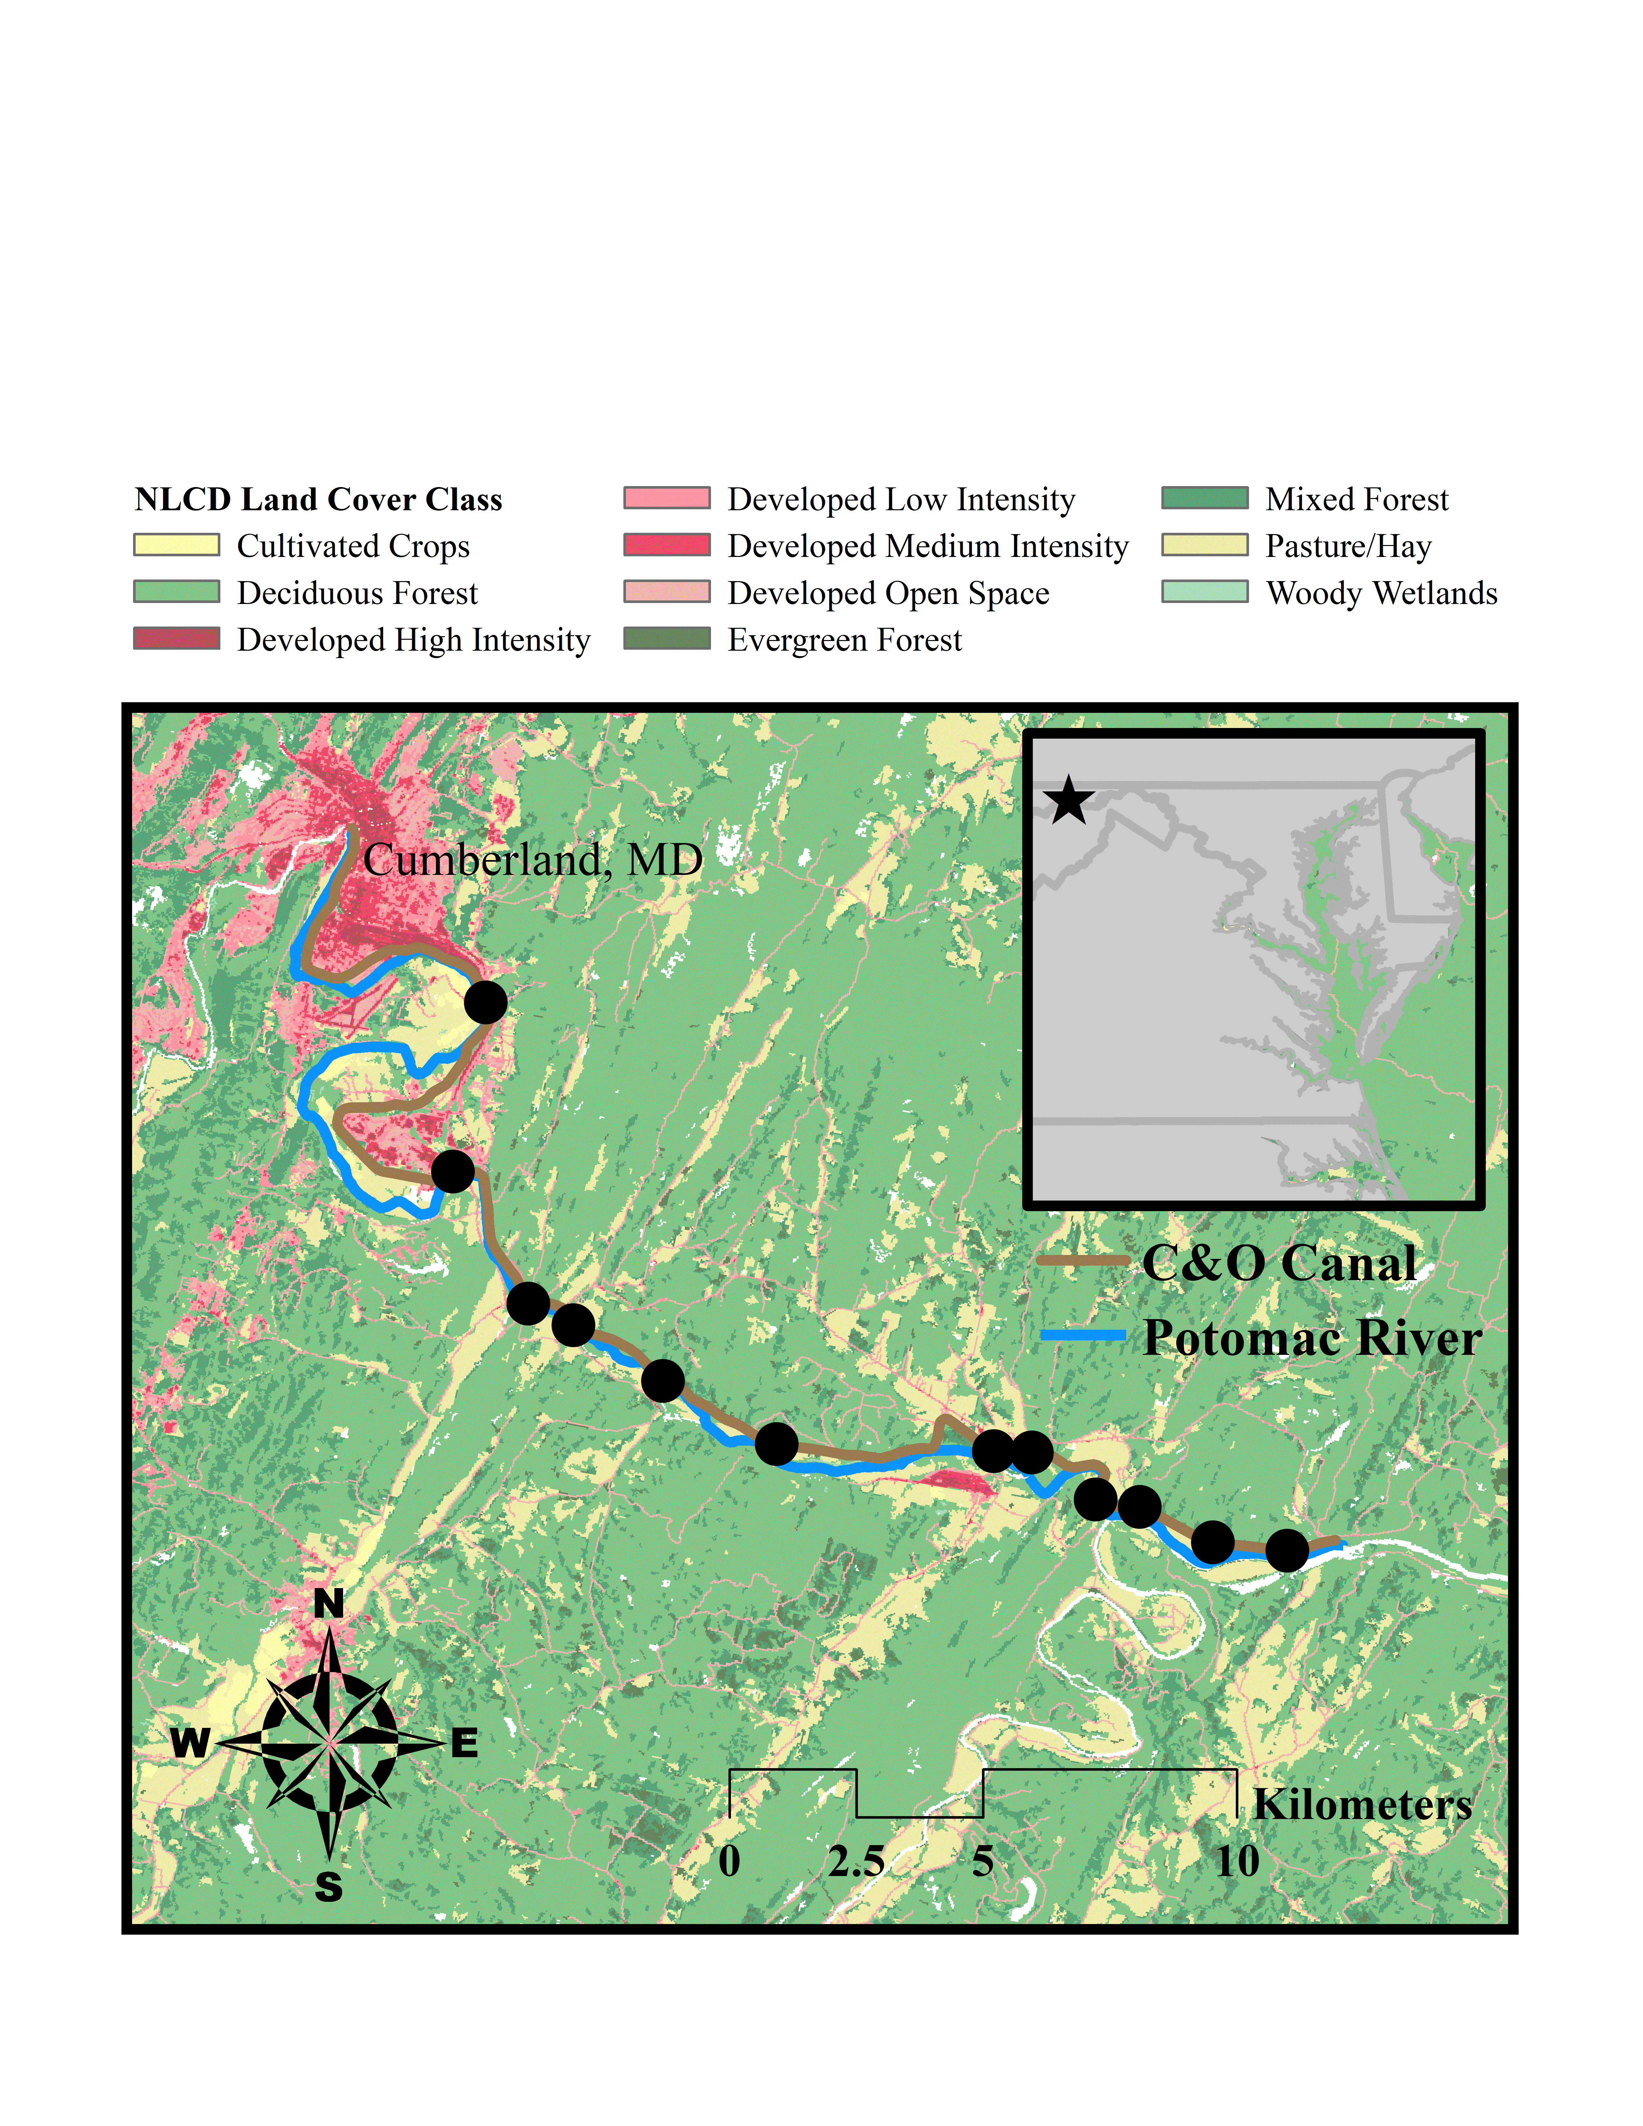

Figure 1. Location of study sites along the Chesapeake and Ohio Canal and distribution of surrounding land cover (United States National Land Cover Database; NLCD 2016, Yang et al. 2018, ESRI 2019).

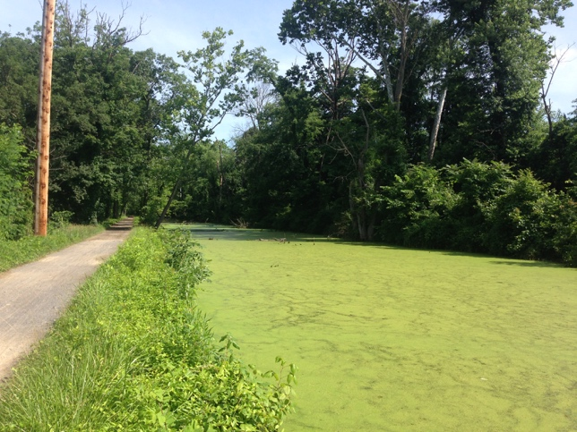 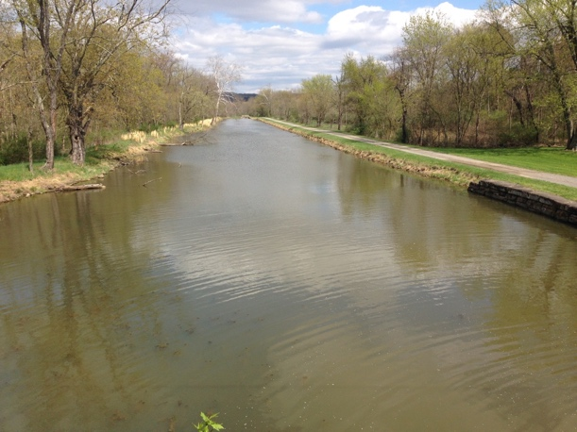

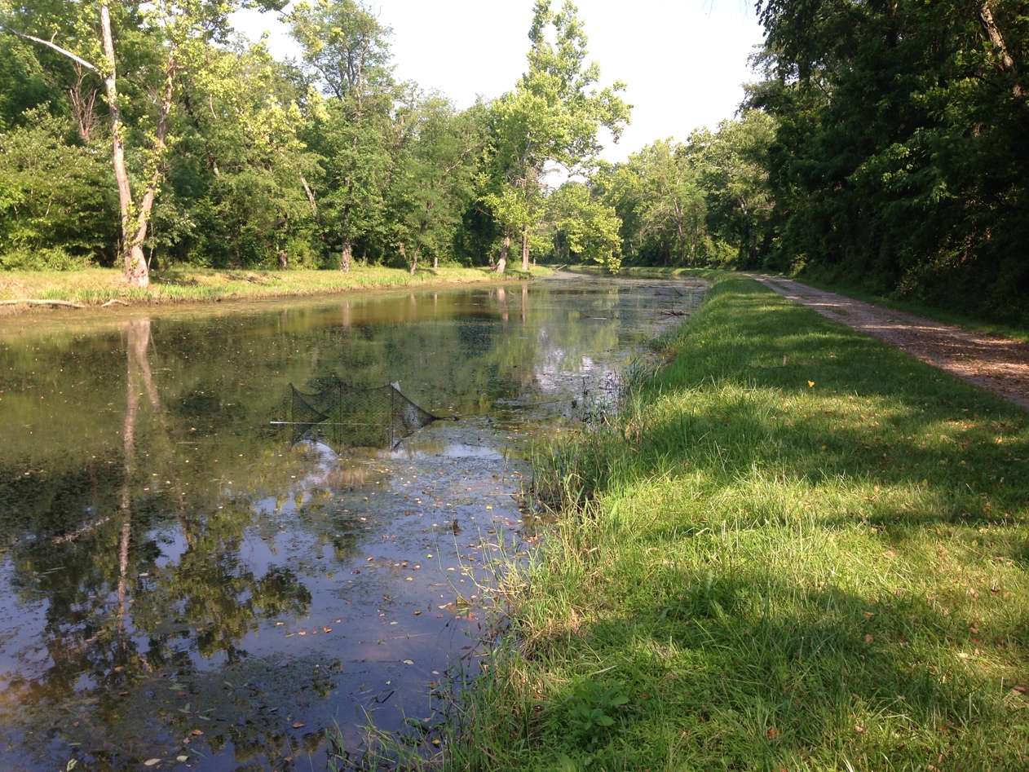

Figure 2. Top left: Site 5; Top right: Site 7; Bottom: Site 4, also displaying deployed traps.

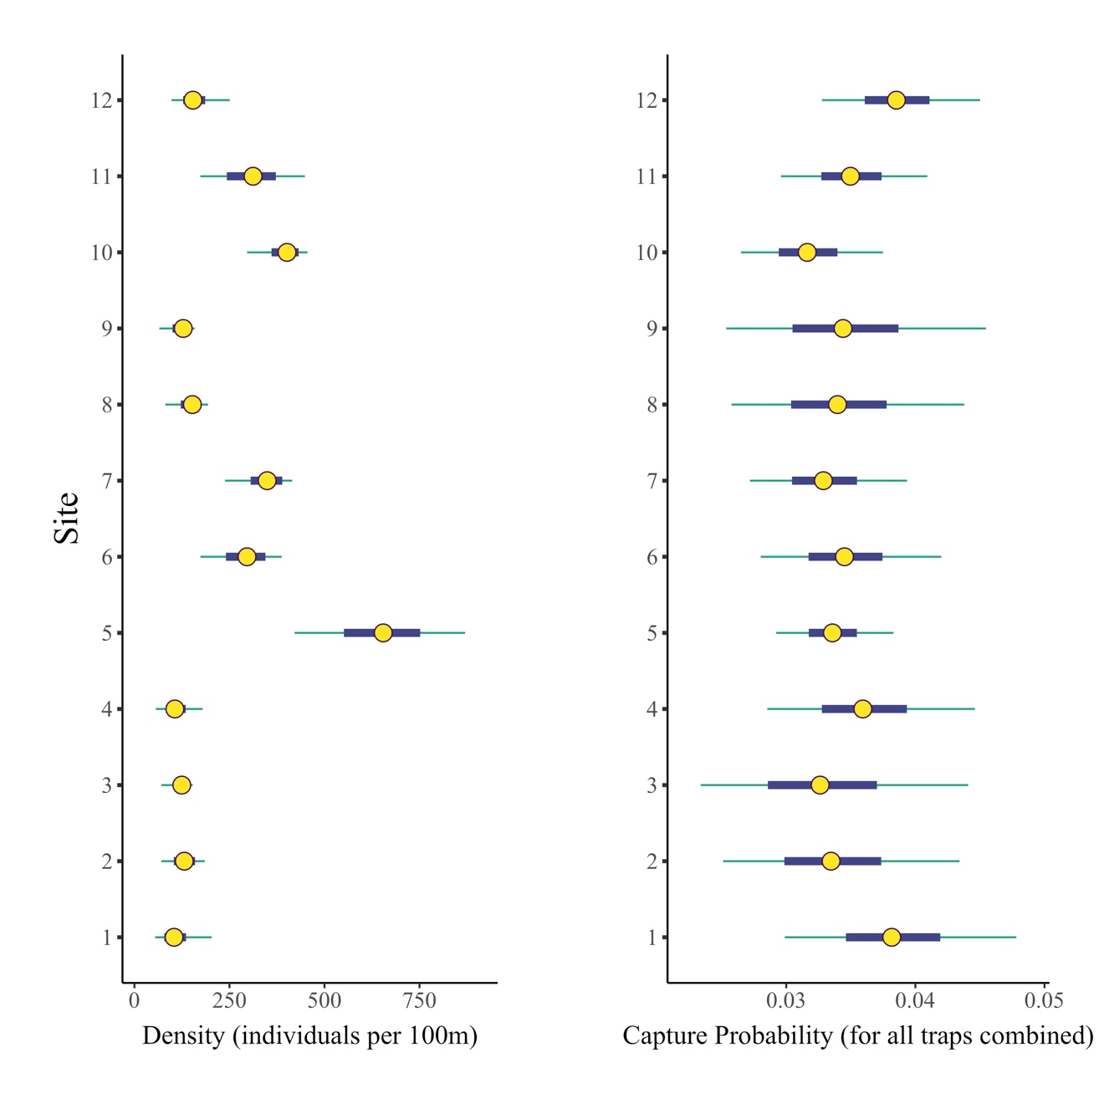Figure 3. Distribution of C. picta density estimates per site and overall capture probability per site (capture probability per trap * number of traps). Yellow center points indicate median values. Dark blue boxes represent values within the 50% credible interval and teal lines represent values within the 90% credible interval.

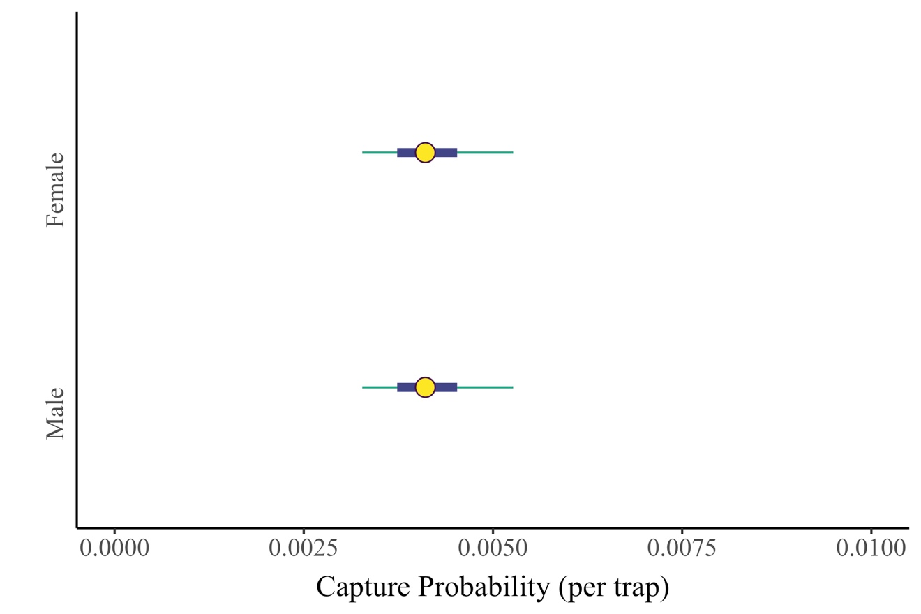

Figure 4. Distribution of C. picta capture probabilities estimated per sex. Yellow center points indicate median values. Dark blue boxes represent values within the 50% credible interval and teal lines represent values within the 90% credible interval.

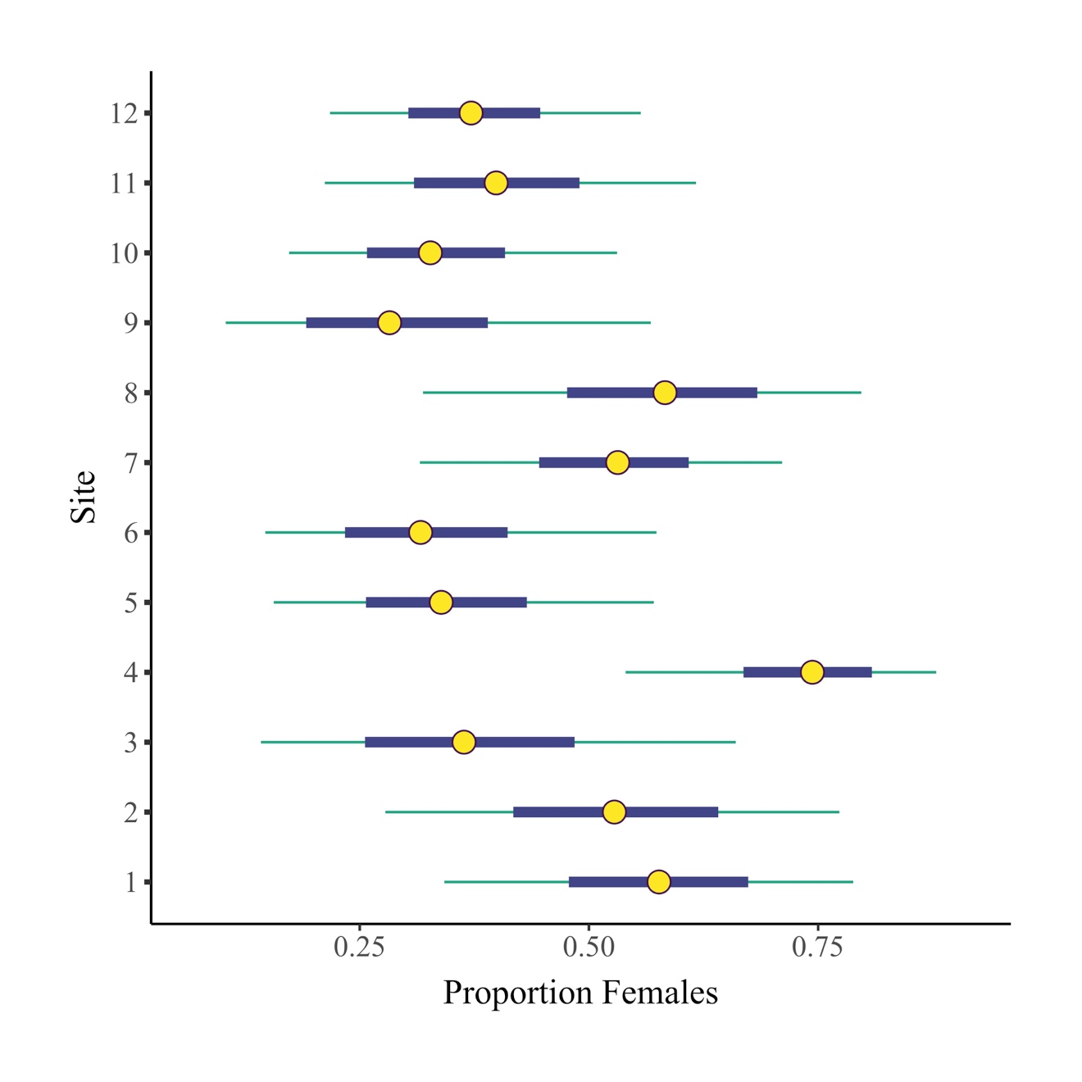

Figure 5. Distribution of proportion of C. picta females estimated per site. Yellow center points indicate median values. Dark blue boxes represent values within a 50% credible interval and teal lines indicate values within a 90% credible interval.

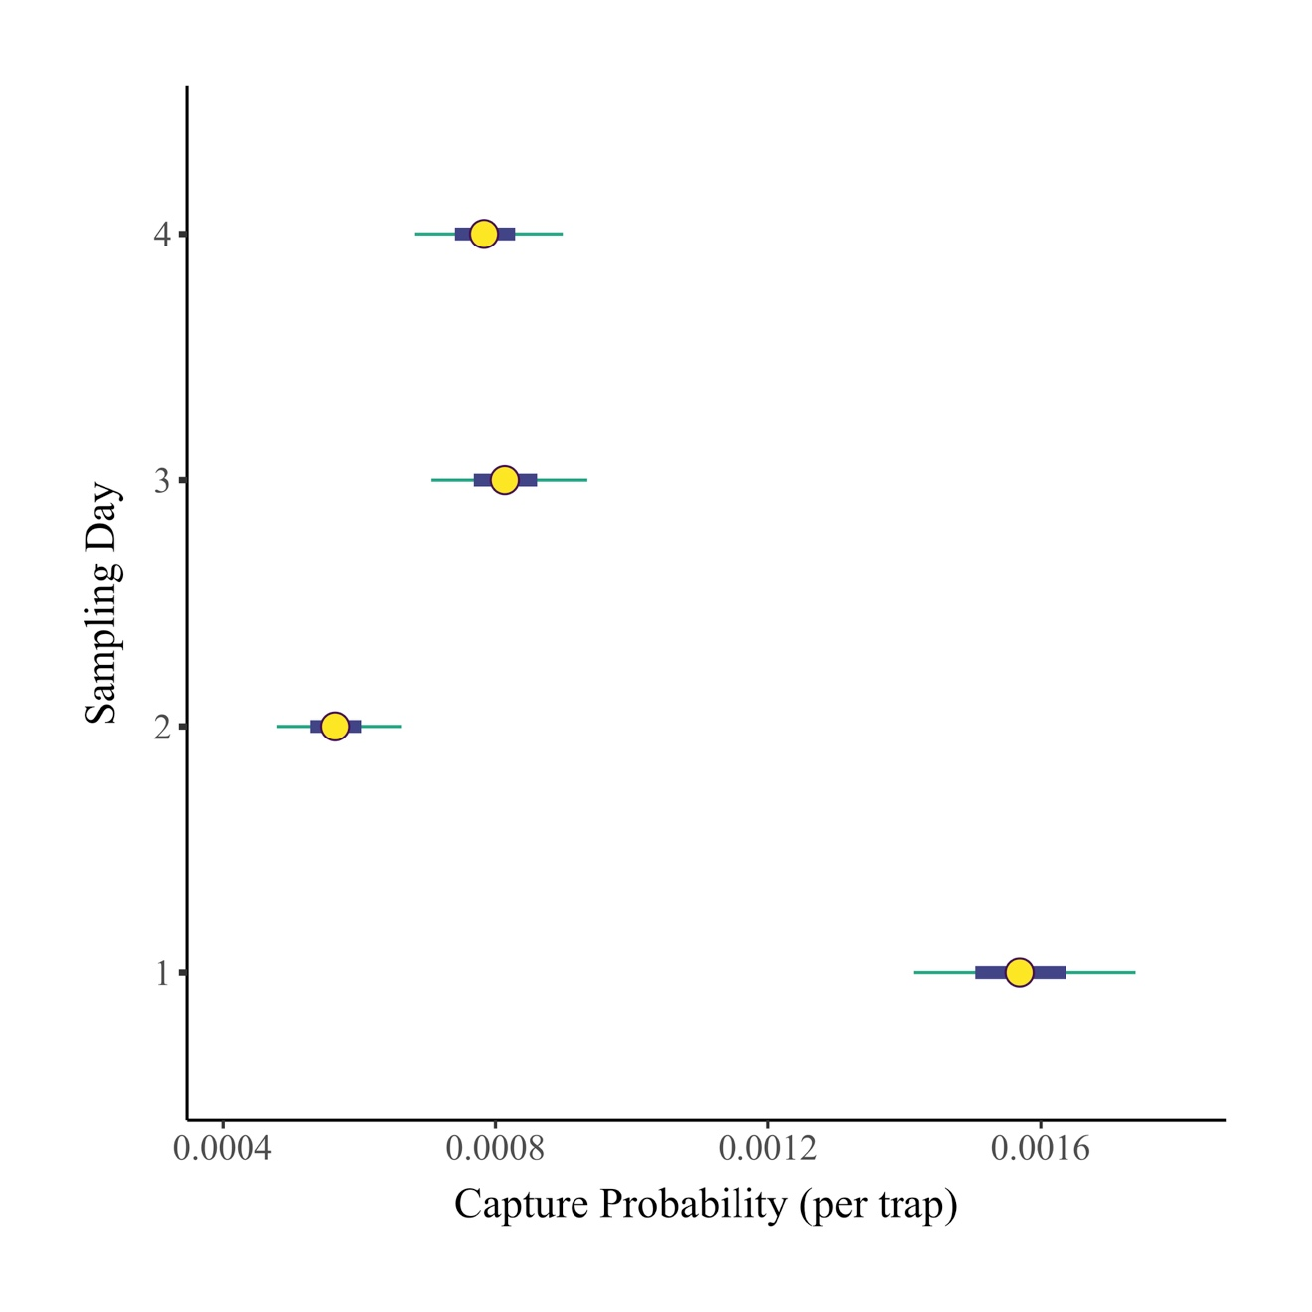Figure 6. Distribution of C. picta capture probability estimates for each of four subsequent sampling days, averaged for all individuals, sexes, and sites. Yellow center points indicate median values. Dark blue boxes represent values within the 50% credible interval and teal lines represent values within the 90% credible interval.

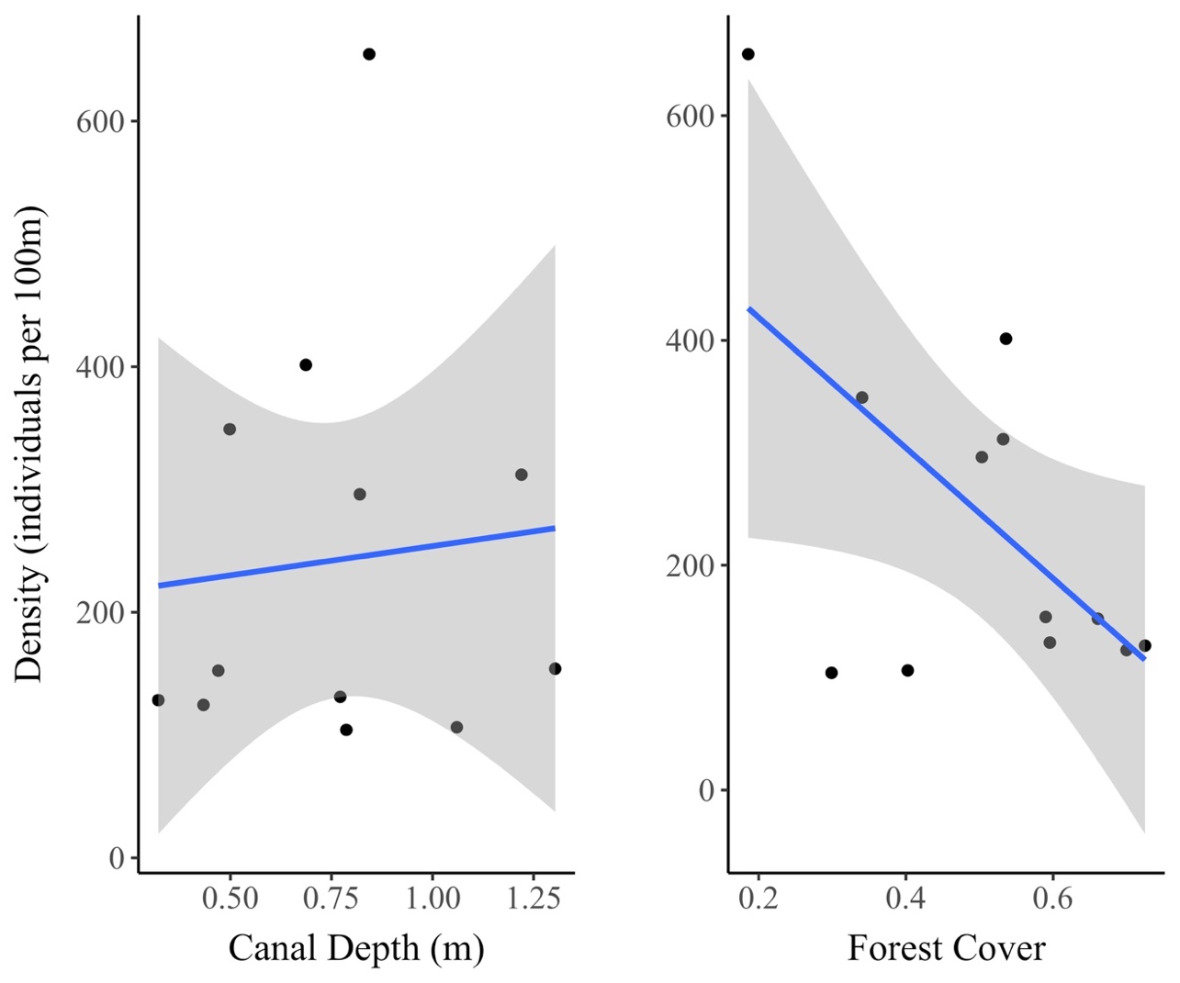

Figure 7. Scatter plots and linear regression lines representing A) C. picta density per site by canal depth and 2) C. picta density per site by forest cover.

## **APPENDIX A**

### **CHAPTER 1 SUPPLEMENTAL TABLES**

Table 4. Secondary sex characteristics of study species. Secondary sex characteristics were used to determine sex of caught individuals. Ratios for C. serpentina calculated as 92% accurate (Dustman 2013).

|  |  |
| --- | --- |
|  | Secondary Sex Characteristics |
| *C. picta,*  *T. scripta elegans,*  *P. rubriventris,*  *P. rubriventris,*  *S. odoratus,*  *C. serpentina* | Males: Longer tail (and often wider) with cloaca further from base (beyond edge of carapace)  Females: Shorter tail with cloaca closer to base |
| *C. picta,*  *T. scripta elegans,*  *P. rubriventris* | Males: Elongated front claws (for courtship behavior)  Females: Non-elongated front claws |
| *C. serpentina* | Males: Ratio of posterior lobe length to precloacal length > 0.86  Females: Ratio of posterior lobe length to precloacal length < 0.86 |

Table 5. Known distributions and conservation threats of aquatic turtles found in the Chesapeake and Ohio National Historic Park (Ernst and Lovich 2009).

|  |  |  |
| --- | --- | --- |
| Species | Known Distribution | Threats or Associated Concerns |
| *C. serpentina* | Common in waterways throughout North America east of the Rocky Mountains. | While often found at healthy populations sizes, some populations have been decimated due to over-harvest for consumption. |
| *C. picta* | *C. picta picta* – east coast south to Georgia and Alabama; *C. picta marginata* – central US to western New Hampshire, western Massachusetts, eastern Pennsylvania, West Virginia, and Tennessee. | Often the most abundant species in suitable habitat across its range. Competition with *T. scripta elegans* may lead to lower population densities. |
| *T. scripta elegans* | Widely distributed throughout the Southeastern U.S. from Texas to eastern North Carolina.  Native range: Mississippi River Basin. | Introduced throughout much of the U.S. potentially competing with and causing declines of co-inhabiting native species. |
| *P. rubriventris* | Disjunct distribution:  Atlantic Coastal Plain from central New Jersey to northeastern North Carolina  Relict population found in Massachusetts | Small range and disjunct population has led to low genetic diversity providing decreased adaptation potential. Massachusetts colonies now protected under the Endangered Species Act. |
| *S. odoratus* | Common in the eastern half of the U.S. from eastern Texas and Wisconsin. | Population seem to be relatively stable currently with only a few declines. Listed as threatened in Iowa and protected in Vermont and Quebec. |
| *G. insculpta* | Found in Northeastern US into parts of Canada (Nova Scotia and New Brunswick south to northern Virginia and west to northeastern Iowa). | Habitat destruction and over-collection for pet trade have led to declining populations through much of range. Relatively slow growth and age of maturation (14-18 years) exacerbate these threats. |

Table 6. Species Characteristics. Mean daily distances moved from previous literature for C. serpentina, C. picta, T. scripta elegans, and S. odoratus. Distances calculated from radio-tracking data unless otherwise noted. No mean daily distances could be found for P. rubriventris. J = juvenile, F = female, M = male, m = meters.

|  |  |  |
| --- | --- | --- |
| Species  and Source | Location | Mean Daily Distance Moved |
| *C. serpentina*  Ernst 1968  Pettit et al. 1995  Steen et al. 2010  Anthonysamy 2012 | Pennsylvania  Lake Ontario, Canada: Cootes Paradise  Ichauway, GA  Illinois | 74.5 m (Mean distance for 16 recaptures)  F: 588/7 +/- 607/7; M: 209/7 +/- 235/7 m  160 m, 151m (and 600 m), 131m (Individual observations of max distance moved)  M: 28.3; F: 42.3 m |
| *C. Picta*  Rowe 2003  Jaeger and Cobb 2012  Rowe and Dalgarn 2010  Anthonysamy 2012 | Michigan  Tennessee: Reelfoot Lake  Michigan: Miller’s Marsh  Illinois: Lower Des Plaines river valley – 3 preserves | 68.1 m (1999: 102 m; 2000: 39 m)  83.9 m  J: 89.8; F: 81.2; M: 96.5 m  M: 70.8; F: 24.0 m |
| *T. scripta*  Jaeger and Cobb 2012  Haas 2015  Ryan et al. 2008 | Tennessee  New York  Indiana | 212.9 m  Spring: 39, 49, 91, 141; Summer: 47, 37, 36, 85;  Fall: 22, 35, 13, 19;  Total means: 38, 37, 43, 77 m  M: ~ 350; F: ~ 250 m |
| *S. odoratus*  Mahmoud 1969  Belleau 2008  Anthonysamy 2012 | Oklahoma  Québec  Illinois | M: 68; F: 68  M: 38; F: 36.6 m  M: 36.3; F: 30.0 m |

Table 7. Species Characteristics, reproductive traits, feeding type, and IUCN conservation status of aquatic turtles found in the Chesapeake and Ohio National Historic Park (Buhlmann et al. 2008, Ernst and Lovich 2009, IUCN 2017).

|  |  |  |  |
| --- | --- | --- | --- |
| Species | Fecundity/Reproduction | Feeding Type  (of adult) | IUCN Status |
| *C. serpentina* | 1 clutch of 25-45 eggs; 75-95 day incubation | Generalist – known to eat smaller turtles | Least Concern |
| *C. picta* (2) | 2 clutches of 1-11 or 3-17 (C. p. picta and C. p. marginata respectively) eggs; 62-80 day incubation | Omnivorous Generalist | Least Concern |
| *T. scripta elegans* | 1-5 clutches of 1-30 eggs; 60-91 day incubation | Omnivorous Generalist | Least Concern; Introduced in many locations |
| *P. rubriventris* | 1-2 clutches of 4-35 eggs; 42-121 day incubation | Exclusively Herbivorous | Near Threatened |
| *S. odoratus* | 1-6 clutches of 2-4 eggs; 60-86 day | Preferentially Carnivorous Omnivores – Prefer Mollusks | Least Concern |
| *G. insculpta* | 1 clutch of 3-20 eggs; 42-82 day incubation | Omnivorous – known to “drum up” earthworms | Endangered |
| *C. guttata* | 1-2 clutches of 3-5 eggs; 50-90 day incubation | Omnivorous – Prefer small live animals | Endangered |

Table 8. Coordinates taken on the canal bank adjacent to the most upstream trap (direction = towards Cumberland, MD) for each sampled site.

|  |  |  |
| --- | --- | --- |
| Site | Latitude | Longitude |
| 1 | 39.5874442 | -78.740503 |
| 2 | 39.5619245 | -78.711878 |
| 3 | 39.5407594 | -78.665198 |
| 4 | 39.5406772 | -78.616022 |
| 5 | 39.6186165 | -78.733178 |
| 6 | 39.5322934 | -78.591028 |
| 7 | 39.5399321 | -78.60704 |
| 8 | 39.5651839 | -78.722925 |
| 9 | 39.5519732 | -78.691634 |
| 10 | 39.5310063 | -78.582285 |
| 11 | 39.5249336 | -78.565104 |
| 12 | 39.5233097 | -78.548033 |

Table 9. Mean and median values for mass and carapace length (CL) and number of recaptures of C. picta, C. serpentina, P. rubriventris, and S. odoratus captured from all sites. For mass and carapace length, data in parentheses represent standard deviations. Data in brackets represent minimum and maximum values. For recaptures, data in parentheses represent percent of total captures. F = female, M = male, and U = undetermined.

|  |  |  |  |  |  |  |  |  |  |  |  |
| --- | --- | --- | --- | --- | --- | --- | --- | --- | --- | --- | --- |
|  | CPIC | | | CSER | | | SODO | | PRUB | | |
|  | **F (n=236)** | **M (n=555)** | **U (n=16)** | **F (n=39)** | **M (n=34)** | **U (n=1)** | **F (n=43)** | **M (n=84)** | **F (n=43)** | **M (n=84)** | **U (n=1)** |
| Mean  Mass (g) | 362  (103) | 232  (56.2) | 59.1 (25.6) | 3830 (1660) | 8120 (3590) | 170  (NA) | 153  (45.9) | 145  (52.8) | 1660 (1040) | 1600  (698) | 130  (NA) |
| Median Mass (g) | 375  [50.0,  625] | 240  [30.0, 430] | 57.5  [15.0, 110] | 3890  [265, 7020] | 8120  [810, 15200] | 170  [170,  170] | 140  [40.0, 250] | 145  [40.0, 260] | 1540  [140, 3770] | 1550  [90.0, 3520] | 130  [130,  130] |
| Mean  CL (mm) | 140  (16.2) | 124  (11.7) | 73.9 (12.3) | 249  (46.0) | 320  (46.1) | 93.0  (NA) | 97.5 (10.0) | 100  (12.8) | 226  (59.8) | 235  (39.1) | 93.0  (NA) |
| Median  CL (mm) | 144  [73.0, 172] | 126  [72.0, 151] | 75.5  [50.0, 96.0] | 261  [110,  314] | 324  [218,  390] | 93.0  [93.0, 93.0] | 96.0  [64.0, 123] | 99.5  [69.0, 128] | 243  [95.0, 314] | 243  [85.0,  290] | 93.0  [93.0,  93.0] |
| Recaps (number caught) | 28 (11.9%) | 85 (15.3%) | 0  (0%) | 7  (17.9%) | 4  (11.8%) | 0  (0%) | 48 (94.1%) | 27 (96.4%) | 7  (16.3%) | 10  (11.9%) | 1  (100%) |

Table 10. All saved model output with associated means, standard deviations (sd), 2.5%, 50%, and 97.5% credible intervals, $\hat{R}$ values (Rhat), and effective sampling sizes (n.eff). Brackets indicate index of site (1:12) or sex (1:2).

|  | **mean** | **sd** | **2.5%** | **50%** | **97.5%** | **Rhat** | **n.eff** |
| --- | --- | --- | --- | --- | --- | --- | --- |
| $N$ [1] | 530.02 | 209.75 | 230 | 495 | 1060 | 1.03 | 198 |
| $N$ [2] | 660.87 | 179.29 | 314 | 665 | 955 | 1.03 | 188 |
| $N$ [3] | 559.32 | 120.2 | 285 | 580 | 721 | 1.04 | 217 |
| $N$ [4] | 672.99 | 225.33 | 306 | 648 | 1171 | 1.03 | 210 |
| $N$ [5] | 2956.18 | 615.9 | 1776 | 2979 | 4084 | 1.12 | 81 |
| $N$ [6] | 1256.37 | 289 | 674 | 1281 | 1705 | 1.09 | 123 |
| $N$ [7] | 1802.79 | 291.99 | 1158 | 1838 | 2207 | 1.1 | 110 |
| $N$ [8] | 747.48 | 180.3 | 360 | 778 | 1003 | 1.07 | 155 |
| $N$ [9] | 626.58 | 153.81 | 296 | 661 | 822 | 1.06 | 156 |
| $N$ [10] | 2262.71 | 290.77 | 1586 | 2319 | 2656 | 1.03 | 105 |
| $N$ [11] | 1667.79 | 458.72 | 836 | 1680 | 2572.12 | 1.03 | 100 |
| $N$ [12] | 834.58 | 243.74 | 463 | 797 | 1439.12 | 1.06 | 288 |
| density[1] | 111.61 | 44.17 | 48.43 | 104.23 | 223.21 | 1.03 | 198 |
| density[2] | 130.34 | 35.36 | 61.93 | 131.15 | 188.35 | 1.03 | 188 |
| density[3] | 120.1 | 25.81 | 61.2 | 124.54 | 154.82 | 1.04 | 217 |
| density[4] | 110.47 | 36.99 | 50.23 | 106.37 | 192.23 | 1.03 | 210 |
| density[5] | 649.64 | 135.35 | 390.29 | 654.66 | 897.49 | 1.12 | 81 |
| density[6] | 290.43 | 66.81 | 155.81 | 296.13 | 394.14 | 1.09 | 123 |
| density[7] | 342.43 | 55.46 | 219.96 | 349.12 | 419.21 | 1.1 | 110 |
| density[8] | 146.46 | 35.33 | 70.54 | 152.44 | 196.53 | 1.07 | 155 |
| density[9] | 121.75 | 29.89 | 57.51 | 128.44 | 159.72 | 1.06 | 156 |
| density[10] | 391.72 | 50.34 | 274.57 | 401.46 | 459.8 | 1.03 | 105 |
| density[11] | 309.82 | 85.22 | 155.3 | 312.09 | 477.81 | 1.03 | 100 |
| density[12] | 161.25 | 47.09 | 89.46 | 153.99 | 278.05 | 1.06 | 288 |
| $$α_{2}$$ | 1.77 | 0.17 | 1.42 | 1.78 | 2.1 | 1.03 | 391 |
| $${μ_{α}}_{0 }$$ | -5.72 | 0.21 | -6.12 | -5.72 | -5.3 | 1.01 | 906 |
| $${ σ_{α}}_{0}$$ | 0.8 | 0.11 | 0.62 | 0.8 | 1.04 | 1 | 10733 |
| ${μ_{α}}_{1 }$ [1] | 0 | 1.41 | -2.76 | 0 | 2.76 | 1 | 39194 |
| ${μ_{α}}_{1 }$ [2] | -0.01 | 1.42 | -2.79 | -0.01 | 2.79 | 1 | 39271 |
| $${ σ_{α}}_{1}$$ | 4.37 | 24.01 | 0.04 | 0.99 | 25.18 | 1 | 39730 |
| $α_{0}$ [1,1] | -4.84 | 0.42 | -5.68 | -4.85 | -4.01 | 1.01 | 1194 |
| $α_{0}$ [2,1] | -4.66 | 0.4 | -5.45 | -4.67 | -3.85 | 1.01 | 1677 |
| $α_{0}$ [3,1] | -5.01 | 0.44 | -5.88 | -5.01 | -4.15 | 1 | 3820 |
| $α_{0}$ [4,1] | -5.12 | 0.38 | -5.87 | -5.12 | -4.37 | 1.01 | 1248 |
| $α_{0}$ [5,1] | -4.69 | 0.27 | -5.23 | -4.69 | -4.15 | 1.02 | 1125 |
| $α_{0}$ [6,1] | -4.67 | 0.37 | -5.39 | -4.67 | -3.94 | 1.02 | 1787 |
| $α_{0}$ [7,1] | -5.23 | 0.34 | -5.9 | -5.23 | -4.56 | 1.01 | 1794 |
| $α_{0}$ [8,1] | -4.9 | 0.41 | -5.69 | -4.9 | -4.11 | 1 | 2227 |
| $α_{0}$ [9,1] | -4.92 | 0.43 | -5.76 | -4.93 | -4.08 | 1 | 2522 |
| $α_{0}$ [10,1] | -5.48 | 0.35 | -6.17 | -5.48 | -4.81 | 1 | 2017 |
| $α_{0}$ [11,1] | -5.58 | 0.36 | -6.3 | -5.58 | -4.87 | 1.01 | 1172 |
| $α_{0}$ [12,1] | -3.87 | 0.33 | -4.52 | -3.87 | -3.24 | 1.02 | 1131 |
| $α_{0}$ [1,2] | -5.99 | 0.47 | -6.95 | -5.98 | -5.1 | 1.01 | 2319 |
| $α_{0}$ [2,2] | -6.91 | 0.56 | -8.07 | -6.89 | -5.88 | 1 | 6290 |
| $α_{0}$ [3,2] | -6.19 | 0.52 | -7.24 | -6.18 | -5.21 | 1 | 6100 |
| $α_{0}$ [4,2] | -6.38 | 0.43 | -7.24 | -6.37 | -5.56 | 1 | 2360 |
| $α_{0}$ [5,2] | -6.22 | 0.31 | -6.82 | -6.22 | -5.62 | 1.01 | 1707 |
| $α_{0}$ [6,2] | -5.61 | 0.4 | -6.41 | -5.61 | -4.83 | 1.01 | 2737 |
| $α_{0}$ [7,2] | -5.96 | 0.36 | -6.67 | -5.95 | -5.26 | 1.01 | 2274 |
| $α_{0}$ [8,2] | -6 | 0.46 | -6.93 | -6 | -5.13 | 1 | 4140 |
| $α_{0}$ [9,2] | -6.33 | 0.52 | -7.38 | -6.31 | -5.35 | 1 | 5433 |
| $α_{0}$ [10,2] | -6.8 | 0.43 | -7.66 | -6.79 | -5.99 | 1 | 3415 |
| $α_{0}$ [11,2] | -5.77 | 0.36 | -6.48 | -5.77 | -5.06 | 1.01 | 1301 |
| $α_{0}$ [12,2] | -5.73 | 0.36 | -6.44 | -5.72 | -5.04 | 1.01 | 1770 |
| $α_{0}$ [1,3] | -5.19 | 0.4 | -5.99 | -5.18 | -4.41 | 1.01 | 1460 |
| $α_{0}$ [2,3] | -6.33 | 0.48 | -7.31 | -6.31 | -5.42 | 1 | 3981 |
| $α_{0}$ [3,3] | -5.72 | 0.47 | -6.66 | -5.71 | -4.83 | 1 | 5140 |
| $α_{0}$ [4,3] | -6.05 | 0.4 | -6.84 | -6.04 | -5.28 | 1.01 | 1898 |
| $α_{0}$ [5,3] | -6.71 | 0.34 | -7.39 | -6.7 | -6.06 | 1.01 | 2261 |
| $α_{0}$ [6,3] | -5.13 | 0.37 | -5.86 | -5.13 | -4.41 | 1.01 | 2258 |
| $α_{0}$ [7,3] | -5.96 | 0.36 | -6.66 | -5.96 | -5.26 | 1.01 | 2243 |
| $α_{0}$ [8,3] | -6.5 | 0.51 | -7.54 | -6.48 | -5.54 | 1 | 4853 |
| $α_{0}$ [9,3] | -5.42 | 0.43 | -6.27 | -5.42 | -4.59 | 1 | 3177 |
| $α_{0}$ [10,3] | -5.42 | 0.34 | -6.09 | -5.42 | -4.77 | 1 | 1948 |
| $α_{0}$ [11,3] | -6.34 | 0.39 | -7.12 | -6.34 | -5.59 | 1.01 | 1913 |
| $α_{0}$ [12,3] | -5.3 | 0.33 | -5.95 | -5.29 | -4.65 | 1.01 | 1392 |
| $α_{0}$ [1,4] | -5.04 | 0.38 | -5.8 | -5.04 | -4.29 | 1.01 | 1326 |
| $α_{0}$ [2,4] | -6.07 | 0.45 | -6.99 | -6.06 | -5.21 | 1 | 3551 |
| $α_{0}$ [3,4] | -6.09 | 0.49 | -7.09 | -6.08 | -5.16 | 1 | 5460 |
| $α_{0}$ [4,4] | -6.36 | 0.42 | -7.2 | -6.35 | -5.56 | 1.01 | 2075 |
| $α_{0}$ [5,4] | -6.3 | 0.31 | -6.91 | -6.3 | -5.71 | 1.01 | 1766 |
| $α_{0}$ [6,4] | -5.8 | 0.4 | -6.61 | -5.8 | -5.02 | 1.01 | 3131 |
| $α_{0}$ [7,4] | -6.89 | 0.43 | -7.76 | -6.88 | -6.07 | 1.01 | 3700 |
| $α_{0}$ [8,4] | -5.71 | 0.42 | -6.55 | -5.71 | -4.9 | 1 | 3307 |
| $α_{0}$ [9,4] | -6.82 | 0.57 | -8.01 | -6.8 | -5.79 | 1 | 6099 |
| $α_{0}$ [10,4] | -5.72 | 0.34 | -6.4 | -5.72 | -5.06 | 1 | 1998 |
| $α_{0}$ [11,4] | -4.8 | 0.32 | -5.42 | -4.8 | -4.17 | 1.01 | 977 |
| $α_{0}$ [12,4] | -6.2 | 0.39 | -6.98 | -6.19 | -5.46 | 1.01 | 2227 |
| $α_{1}$ [1,1] | 0.5 | 0.45 | 0.02 | 0.38 | 1.68 | 1.01 | 1591 |
| $α_{1}$ [2,1] | 0.72 | 0.59 | 0.04 | 0.56 | 2.24 | 1.01 | 2066 |
| $α_{1}$ [3,1] | 1.26 | 1.28 | 0.06 | 0.88 | 4.7 | 1.01 | 2213 |
| $α_{1}$ [4,1] | 0.22 | 0.19 | 0.01 | 0.17 | 0.74 | 1 | 3030 |
| $α_{1}$ [5,1] | 0.41 | 0.31 | 0.04 | 0.33 | 1.23 | 1.01 | 1008 |
| $α_{1}$ [6,1] | 2.34 | 1.61 | 0.25 | 1.99 | 6.41 | 1.01 | 1272 |
| $α_{1}$ [7,1] | 0.6 | 0.46 | 0.05 | 0.49 | 1.78 | 1.01 | 1346 |
| $α_{1}$ [8,1] | 0.78 | 0.6 | 0.03 | 0.65 | 2.29 | 1.01 | 2362 |
| $α_{1}$ [9,1] | 1.98 | 1.79 | 0.16 | 1.5 | 6.7 | 1.01 | 1783 |
| $α_{1}$ [10,1] | 1.68 | 1.08 | 0.31 | 1.44 | 4.36 | 1 | 1400 |
| $α_{1}$ [11,1] | 0.78 | 0.41 | 0.06 | 0.75 | 1.68 | 1.02 | 1565 |
| $α_{1}$ [12,1] | 0.93 | 0.51 | 0.12 | 0.88 | 2.08 | 1.01 | 1386 |
| $α_{1}$ [1,2] | 0.79 | 0.68 | 0.02 | 0.63 | 2.51 | 1 | 919 |
| $α_{1}$ [2,2] | 2.81 | 5.24 | 0.11 | 1.45 | 13.88 | 1.25 | 1135 |
| $α_{1}$ [3,2] | 3.35 | 7.95 | 0.1 | 1.52 | 16.95 | 1.02 | 1044 |
| $α_{1}$ [4,2] | 0.46 | 0.38 | 0.03 | 0.36 | 1.43 | 1.01 | 1409 |
| $α_{1}$ [5,2] | 3.26 | 4.01 | 0.15 | 1.96 | 14.38 | 1.07 | 524 |
| $α_{1}$ [6,2] | 1.51 | 1.42 | 0.04 | 1.12 | 5.31 | 1.01 | 1364 |
| $α_{1}$ [7,2] | 2.17 | 2.25 | 0.18 | 1.51 | 8.39 | 1.01 | 918 |
| $α_{1}$ [8,2] | 2.94 | 3.42 | 0.16 | 1.83 | 12.84 | 1.01 | 1288 |
| $α_{1}$ [9,2] | 1.1 | 1.02 | 0.05 | 0.82 | 3.81 | 1.01 | 2861 |
| $α_{1}$ [10,2] | 2.92 | 3.14 | 0.25 | 1.94 | 12.07 | 1.01 | 966 |
| $α_{1}$ [11,2] | 1.52 | 1.34 | 0.1 | 1.16 | 5.06 | 1.01 | 738 |
| $α_{1}$ [12,2] | 0.82 | 0.54 | 0.07 | 0.72 | 2.12 | 1.01 | 1758 |
| $$α_{3}$$ | -0.29 | 0.23 | -0.75 | -0.29 | 0.17 | 1.01 | 1079 |
| $$β_{1}$$ | -0.59 | 0.49 | -1.56 | -0.6 | 0.37 | 1.01 | 883 |
| $$β_{2}$$ | 0.01 | 0.53 | -1.05 | 0.02 | 1.02 | 1.02 | 556 |
| $ψ_{sex}$ [1] | 0.57 | 0.14 | 0.3 | 0.58 | 0.82 | 1 | 576 |
| $ψ_{sex}$ [2] | 0.53 | 0.15 | 0.24 | 0.53 | 0.81 | 1.01 | 575 |
| $ψ_{sex}$ [3] | 0.38 | 0.16 | 0.11 | 0.36 | 0.71 | 1 | 680 |
| $ψ_{sex}$ [4] | 0.73 | 0.1 | 0.5 | 0.74 | 0.9 | 1.01 | 660 |
| $ψ_{sex}$ [5] | 0.35 | 0.13 | 0.13 | 0.34 | 0.61 | 1.03 | 199 |
| $ψ_{sex}$ [6] | 0.33 | 0.13 | 0.13 | 0.32 | 0.62 | 1.01 | 399 |
| $ψ_{sex}$ [7] | 0.52 | 0.12 | 0.28 | 0.53 | 0.74 | 1.01 | 400 |
| $ψ_{sex}$ [8] | 0.57 | 0.14 | 0.27 | 0.58 | 0.83 | 1.02 | 597 |
| $ψ_{sex}$ [9] | 0.3 | 0.14 | 0.08 | 0.28 | 0.62 | 1.03 | 679 |
| $ψ_{sex}$ [10] | 0.34 | 0.11 | 0.15 | 0.33 | 0.57 | 1 | 375 |
| $ψ_{sex}$ [11] | 0.4 | 0.12 | 0.19 | 0.4 | 0.66 | 1.03 | 304 |
| $ψ_{sex}$ [12] | 0.38 | 0.1 | 0.2 | 0.37 | 0.59 | 1.01 | 468 |
| $p_{k}$ [1] | 0.002 | 0 | 0.001 | 0.002 | 0.002 | 1 | 33559 |
| $p_{k}$ [2] | 0.001 | 0 | 0 | 0.001 | 0.001 | 1 | 34255 |
| $p_{k}$ [3] | 0.001 | 0 | 0.001 | 0.001 | 0.001 | 1 | 38370 |
| $p_{k}$ [4] | 0.001 | 0 | 0.001 | 0.001 | 0.001 | 1 | 37403 |
| $p_{sex}$ [1] | 0.004 | 0.001 | 0.003 | 0.004 | 0.006 | 1.04 | 463 |
| $p_{sex}$ [2] | 0.004 | 0.001 | 0.003 | 0.004 | 0.006 | 1.04 | 463 |
| $$μ_{ψ_{ }}$$ | 0.002 | 1.41 | -2.78 | 0 | 2.76 | 1 | 40044 |
| $$σ_{ψ}$$ | 102.66 | 18118.16 | 0.06 | 1.49 | 36.92 | 1.29 | 38879 |
| $$μ_{σ_{ }}$$ | 1.03 | 0.76 | 0.74 | 0.97 | 1.64 | 1.2 | 18260 |
| $σ_{g}$ [1] | 1.52 | 7.19 | 0.6 | 1.13 | 4.45 | 1 | 15122 |
| $σ_{g}$ [2] | 0.97 | 0.87 | 0.43 | 0.82 | 2.41 | 1.02 | 9574 |
| $σ_{g}$ [3] | 0.86 | 0.83 | 0.34 | 0.72 | 2.17 | 1.03 | 10197 |
| $σ_{g}$ [4] | 1.9 | 5.01 | 0.85 | 1.55 | 4.8 | 1.26 | 17207 |
| $σ_{g}$ [5] | 1.04 | 0.76 | 0.51 | 0.91 | 2.31 | 1.02 | 4923 |
| $σ_{g}$ [6] | 0.77 | 0.66 | 0.35 | 0.62 | 2.12 | 1.02 | 3651 |
| $σ_{g}$ [7] | 0.96 | 0.81 | 0.46 | 0.84 | 2.14 | 1.08 | 6796 |
| $σ_{g}$ [8] | 0.92 | 0.83 | 0.41 | 0.75 | 2.45 | 1.01 | 6009 |
| $σ_{g}$ [9] | 0.87 | 0.69 | 0.4 | 0.73 | 2.17 | 1.01 | 7918 |
| $σ_{g}$ [10] | 0.62 | 0.3 | 0.33 | 0.57 | 1.16 | 1.01 | 2557 |
| $σ_{g}$ [11] | 0.94 | 0.9 | 0.5 | 0.77 | 2.29 | 1.05 | 3319 |
| $σ_{g}$ [12] | 0.96 | 0.82 | 0.55 | 0.83 | 2.11 | 1.02 | 5135 |
| $σ_{sex}$ [1] | 1.16 | 0.91 | 0.77 | 1.06 | 2.08 | 1.22 | 12714 |
| $σ_{sex}$ [2] | 0.89 | 1.22 | 0.57 | 0.82 | 1.59 | 1 | 12939 |
| $p_{g}$ [1] | 0.038 | 0.005 | 0.028 | 0.038 | 0.05 | 1 | 25068 |
| $p_{g}$ [2] | 0.034 | 0.006 | 0.024 | 0.033 | 0.046 | 1 | 24586 |
| $p_{g}$ [3] | 0.033 | 0.006 | 0.022 | 0.033 | 0.047 | 1 | 24940 |
| $p_{g}$ [4] | 0.036 | 0.005 | 0.027 | 0.036 | 0.046 | 1 | 31172 |
| $p_{g}$ [5] | 0.034 | 0.003 | 0.028 | 0.034 | 0.039 | 1 | 38750 |
| $p_{g}$ [6] | 0.035 | 0.004 | 0.027 | 0.035 | 0.044 | 1 | 35853 |
| $p_{g}$ [7] | 0.033 | 0.004 | 0.026 | 0.033 | 0.041 | 1 | 38040 |
| $p_{g}$ [8] | 0.034 | 0.006 | 0.024 | 0.034 | 0.046 | 1 | 27052 |
| $p_{g}$ [9] | 0.035 | 0.006 | 0.024 | 0.034 | 0.048 | 1 | 25283 |
| $p_{g}$ [10] | 0.032 | 0.003 | 0.026 | 0.032 | 0.039 | 1 | 37485 |
| $p_{g}$ [11] | 0.035 | 0.003 | 0.029 | 0.035 | 0.042 | 1 | 38662 |
| $p_{g}$ [12] | 0.039 | 0.004 | 0.032 | 0.039 | 0.046 | 1 | 39039 |
| deviance | 11251.77 | 178.09 | 10872.87 | 11259.61 | 11582.32 | 1.05 | 352 |

### **CHAPTER 1 SUPPLEMENTAL FIGURES**

Figure 8. MCMC trace plots for model estimated total number of C. picta individuals per site (1:12), derived densities per site (1:12), and estimated capture probability decay rate ($p_{0}$) per site (1:12) and per sex (1:2; 1 = male, 2 = female).

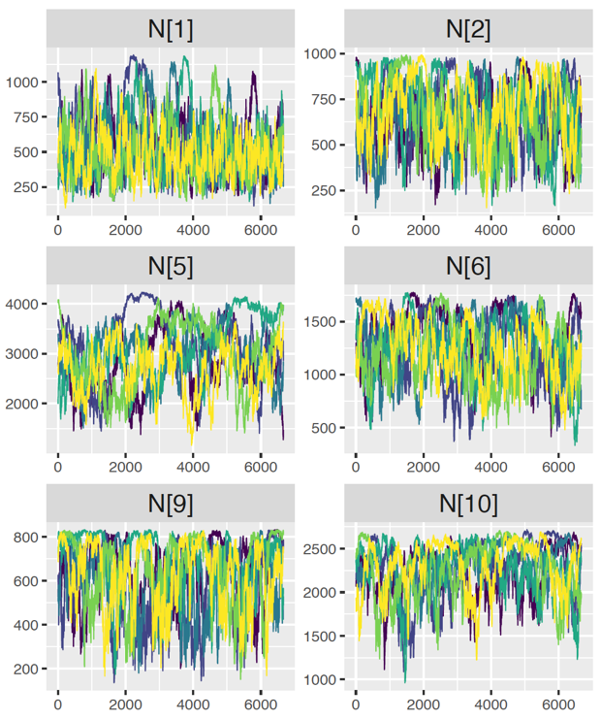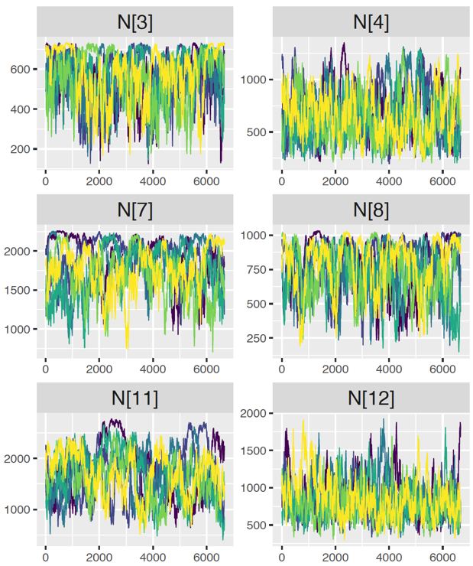

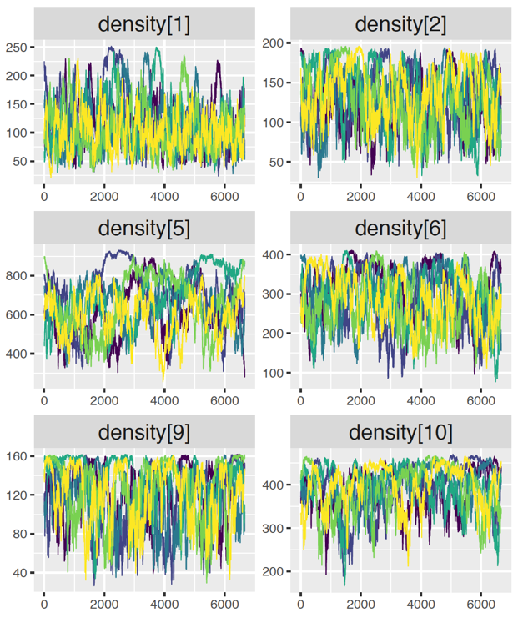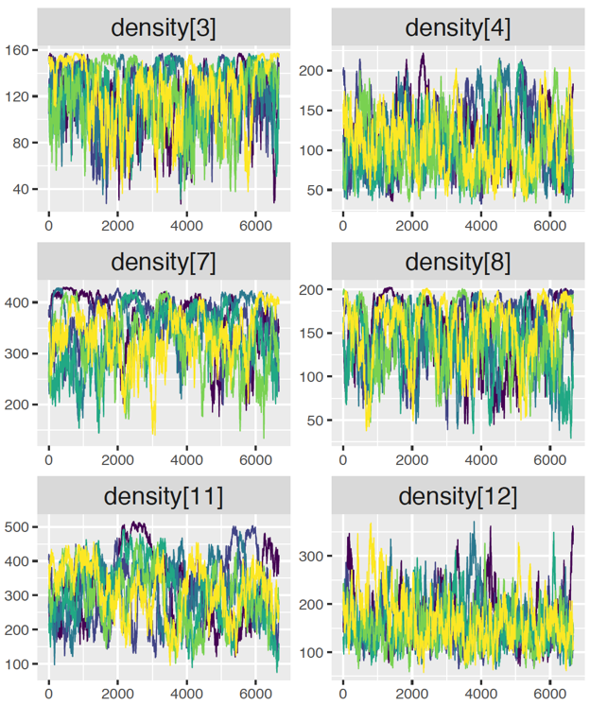

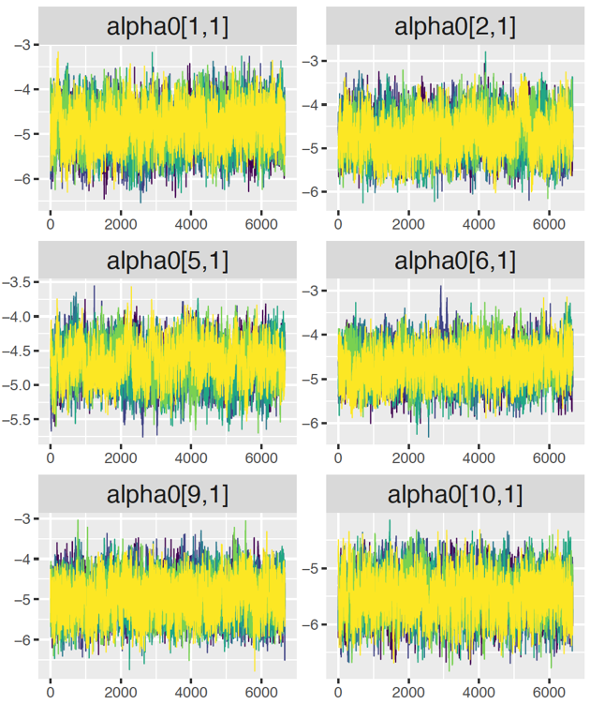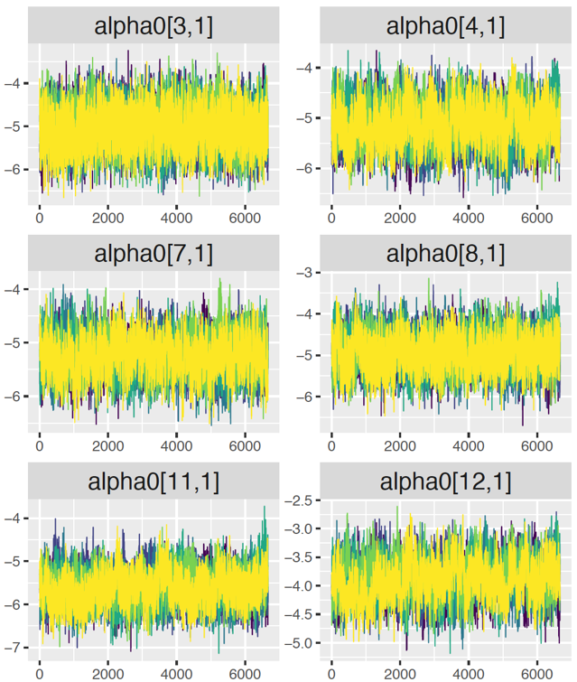

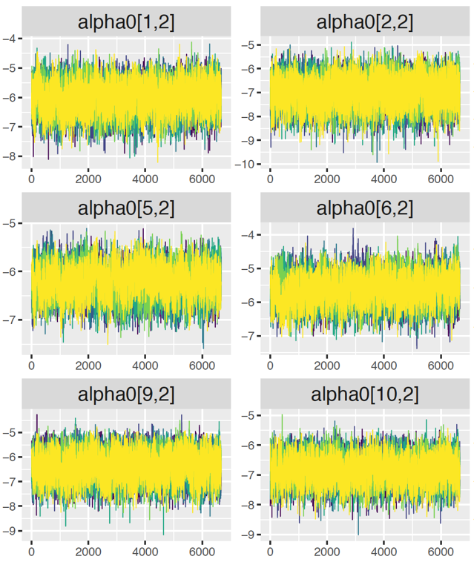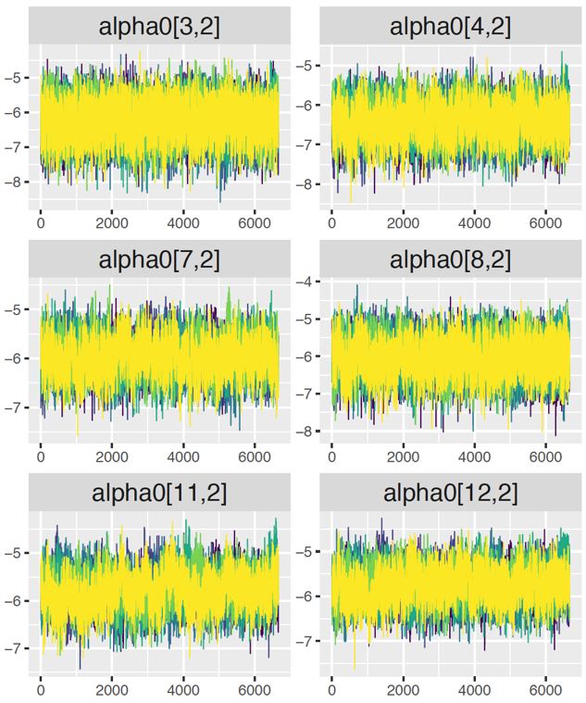

## **APPENDIX B**

### **CHAPTER 1 MODEL TEXT**

The following is a copy of the R script text of our spatial capture-recapture model, last updated October 2019. This model was written using JAGS syntax and was run using the package jagsUI in R Statistical Software (Just Another Gibbs Sampler; Plummer 2003, Kellner 2018, R Core Team 2018). We developed this SCR model to estimate densities and movements of turtles in the Chesapeake and Ohio Canal. The model text and associated object creation and sampling code can be found in the following github repository: <https://github.com/djhocking/co_canal_turtles.git>

model {

mu_a0 ~ dnorm(0, 0.1)

sd_a0 ~ dt(0, pow(1.5, -2), 1)T(0, )

sd_a1 ~ dt(0, pow(1, -2), 1)T(0, 1000)

mu_psi ~ dnorm(0, 0.5)

sd_psi ~ dt(0, pow(1.5, -2), 1)T(0, )

alpha2 ~ dnorm(0, 0.5)

alpha3 ~ dnorm(0, 0.5)

beta1 ~ dnorm(0, 0.5)

beta2 ~ dnorm(0, 0.5)

for(t in 1:2){

mu_a1[t] ~ dnorm(0, 0.5) # fixed intercept differing by sex

}

for(g in 1:n_sites) {

mu_psi_site[g] ~ dnorm(0, 0.5) # independent prior on augmentation intercept - fixed by site

for(k in 1:K) {

alpha0[g, k] ~ dnorm(mu_a0, 1 / sd_a0 / sd_a0)

}

for(i in 1:M[g]) {

Sex[g, i] ~ dbern(psi.sex[g])

Sex2[g, i] <- Sex[g, i] + 1

}

for(t in 1:2){

sigma[g, t] <- pow(1 / (2*alpha1[g, t]), 0.5) # sd of half normal - derived parameter

alpha1[g, t] ~ dt(0, pow(1.5, -2), 1)T(0, )

} # t

logit(psi[g]) <- mu_psi_site[g] + beta1 * depth[g] + beta2 * forest[g]

psi.sex[g] ~ dunif(0, 1)

for(i in 1:M[g]) {

z[g, i] ~ dbern(psi[g])

s[g, i] ~ dunif(xlim[g, 1], xlim[g, 2])

for(j in 1:max_trap[g]) {

d[g,i,j] <- abs(s[g, i] - trap_locs[g, j])

for(k in 1:K) {

for(t in 1:2) {

logit(p0[g, i, j, k, t]) <- alpha0[g, k] + alpha3 * Sex[g, i] + (alpha2 * C[i, k, g])

} # t

} # k

} # j

} # i

for(i in 1:M[g]) {

for (j in 1:max_trap[g]) {

for (k in 1:K) {

y[i, j, k, g] ~ dbern(p[g, i, j, k])

p[g, i, j, k] <- z[g, i] * p0[g, i, j, k, Sex2[g, i]] * exp(- alpha1[g, Sex2[g, i]] * d[g, i,j] * d[g, i,j])

} # i

} # j

} # k

# Derived parameters

N[g] <- sum(z[g , 1:M[g]])

density[g] <- sum(z[g , 1:M[g]]) / (xlim[g, 2] - xlim[g, 1]) # divided distances by 100 so calculates turtles per 100 m of canal

sigma_site[g] <- mean(sigma[g, 1:2])

} # g

for(k in 1:K) {

for(g in 1:n_sites) {

p_cap_site_day[g, k] <- mean(p[g, 1:M[g], 1:max_trap[g], k])

}

p_cap_day[k] <- mean(p_cap_site_day[ , k])

}

for(t in 1:2) {

for(g in 1:n_sites) {

for(i in 1:M[g]) {

p_cap_ind_site_sex[i, g, t] <- mean(p0[g, i, 1:max_trap[g], 1:K, t])

}

p_cap_site_sex[g, t] <- mean(p_cap_ind_site_sex[1:M[g], g, t])

}

p_cap_sex[t] <- mean(p_cap_site_sex[1:n_sites, t])

sigma_sex[t] <- mean(sigma[ , t])

}

sigma_mean <- mean(sigma[ , ])

for(g in 1:n_sites) {

for(i in 1:M[g]) {

p_cap_site_ind[g, i] <- sum(p[g, i, 1:max_trap[g], 1:K])

}

p_cap_site[g] <- mean(p_cap_site_ind[g, 1:M[g]])

}

}